Xv6 Programming Assignment Implementation Log, Testing and User Level Programs

100536625

Table of Contents

User Level Programs 2

Implementation Log and Testing Information 4

# User Level Programs

In this section I will give the exact command that the user should enter in the command line in make qemu to achieve the description. The description tells you what you should expect to be drawn and why it was written. The expected result gives a screen shot of what should be the output once the user level command is entered. I have completed the assignment all the way to the end of stage 3 implementing everything in stage 1,2 and 3 plus added error checking for every possible metric of input and drawing on the screen.

|  |  |  |
| --- | --- | --- |
| User Level Command | Description | Expected Result |
| stage1test | This test will depict a simple white square drawn using the code given at the end of the stage 1 description in the rubric to test that stage 1 was correctly coded and achieved. The only changes I made were to add the setpencolour and selectpen to set the colour. |  |
| stage2colourchangetest | This test was written to test if the first stage of stage 2 was achieved. Which was to implement selectpen and setpencolour. This test will change the colour of the square drawn in stage1test to dark yellow/gold colour since the rgb values set were 50, 50, 0. |  |
| stage2rectfilltest | This test was written to test if the second stage of stage 2 as well as completing the whole of stage 2 was completed. This test will draw a square on the screen in the colour green and fully colour in all the pixels within the square with the same green colour. |  |
| stage3test | This test was written to test if the third stage has been achieved. It demonstrates that the program can handle graphical calls. These graphical calls do not affect other processes made. It also demonstrates the program can handle when coordinates entered go off the screen it can clip them correctly. With this successfully showing shows the completion of stage 3 correctly. |  |
| blackscreentest | This test was originally written to test if in stage 1 I was correctly colouring each pixel in the 320x200 to window to black. |  |
| setpixeltest | This test was written to test if the setpixel function that I implemented was working correctly. In this test 4 coordinates are given and the program goes to each coordinate and changes the colour of the pixel. |  |

# Implementation Log and Testing Information

Tuesday 28th November 2023 – 1:00pm – 3:45pm:

Today I made a start on the preparation before the assignment the tasks for this week will be to clone the assignment starting point from github and go through it understand it. After which make a start on the week 8 tasks. After cloning the repository I spent an hour going through the code base getting a brief understanding off what each class does ect. When reading the exercises for week 8 it said a starting point would be reading the document called working with xv6 in course resources folder for week 8 as it goes through the history of xv6 and how to utlise xv6. I copied this document into my notes:

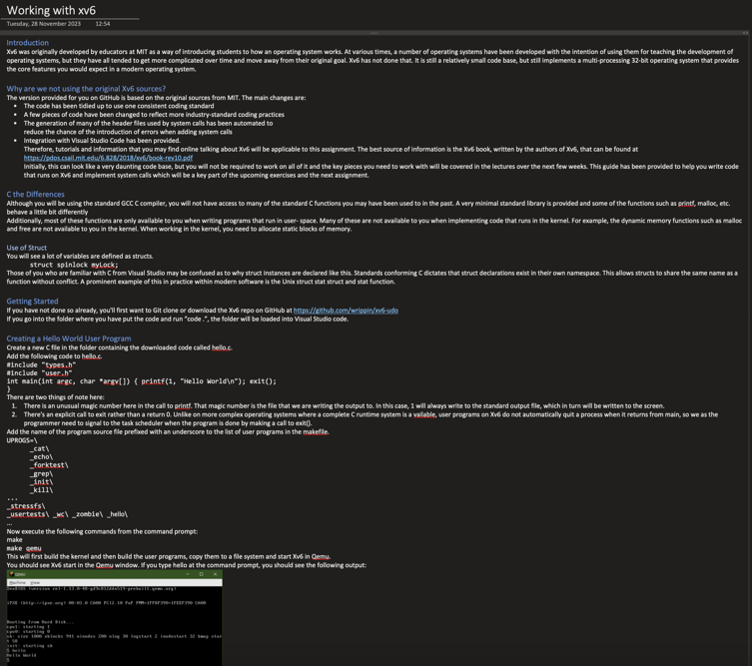

Following this document the first code I implemented into the xv6 code repo was to print hello world which was aided by the working with xv6 document. The following is the code that I implemented, made a new c file called hello.c which called the functionality of the types.h class and user.h class, then is the main function which will print hello world with the number 1 before to tell the compiler we want to print in the standard format. Then theres an exit call to let the complier know that’s all we wanted to print:

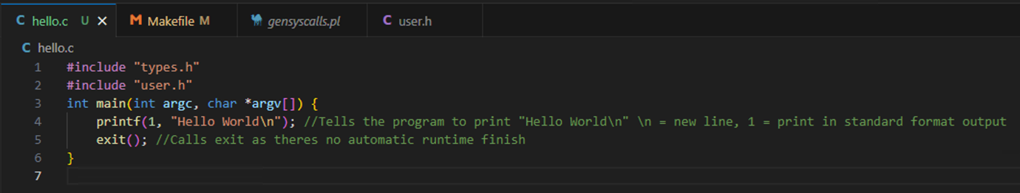

Then to make this function accessible we will add it to the UPROG list of functions in the Makefile, the UPROG stands for user programs to make it a user level program to be utilised:

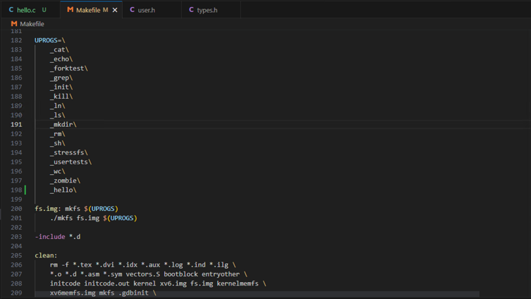

To test the output to make sure it prints hello world as intended I will run the program and put the make command in the terminal then the make qemu command. Once the window pops up we type hello which should print hello world in return:

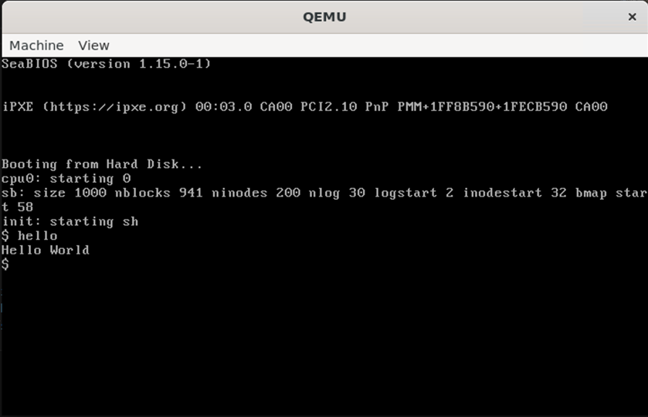

Test Passed

The next exercise in the document is going to teach me how to make a system call. I will be adding a system call called greeting that will print hello again when called. First to declare a new function in the gensyscalls.pl with all the other system calls.

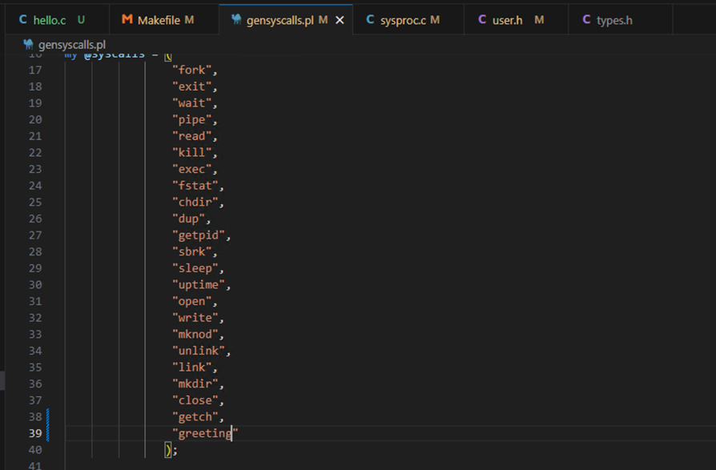

After which I added the new system call with all the others in the user.h file. We declare it as void since we are not taking any inputs:

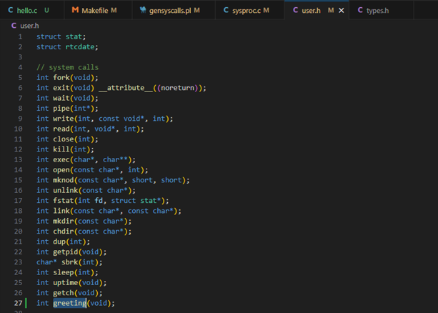

I then added in the code of the code to print hello again in the sysproc.c file which is one of the files used to write to the kernel:

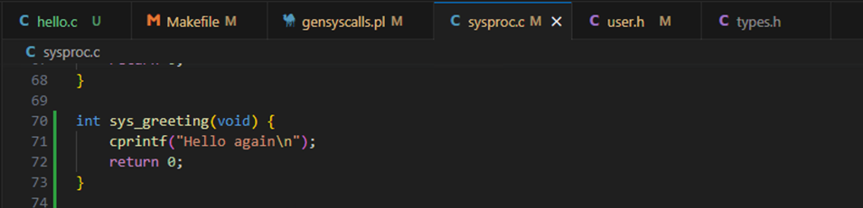

Finally now in the hello.c function we can remove the print statement and add the call to the greeting function:

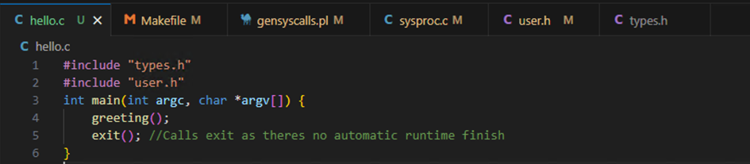

To test if this works when we call the hello on the command line when compiled it should now print “hello again”:

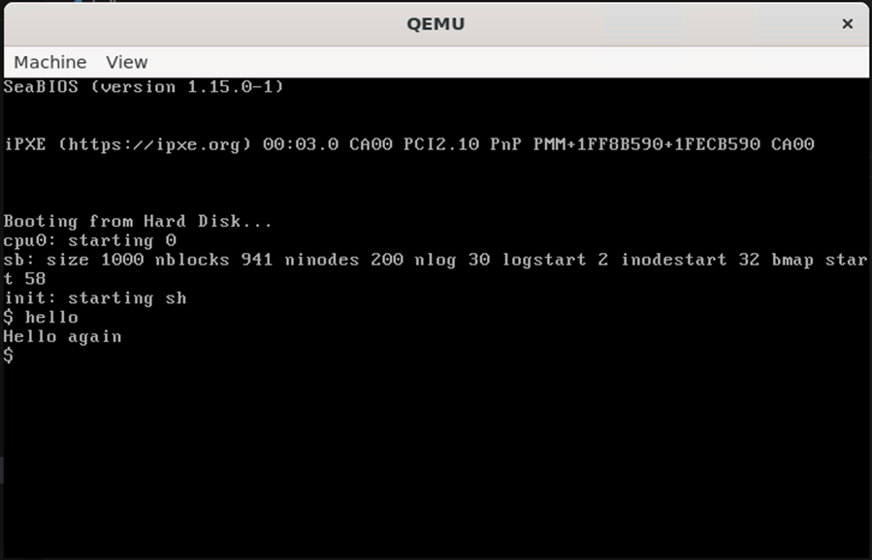

Test passed

That was all the information given in the xv6 document.

Thursday 30th November 2023 – 11:25am – 4:13pm:

Todays tasks were to complete the week 8 tasks. The first task of week 8 is to create a new system call that will allow the user to call shutdown and will shutdown the program. This is how I went about creating a system call to do this. First I defined the new call in user.h, Makefile, gensyscalls.pl:

Makefile:

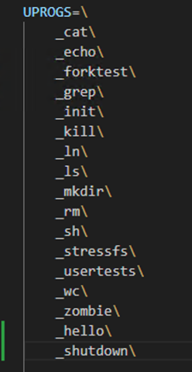

Gensyscalls.pl:

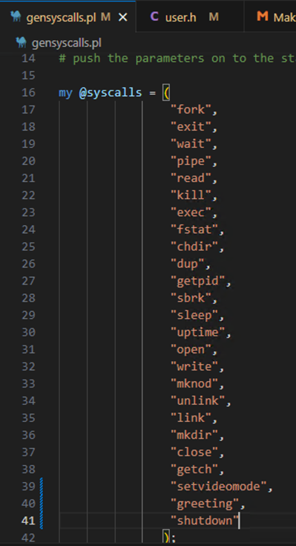

User.h:

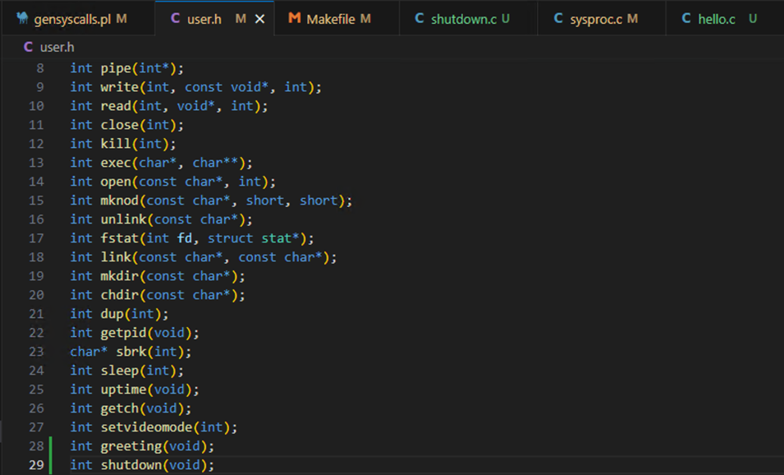

Then I made a shutdown.c class which calls shutdown and then exits:

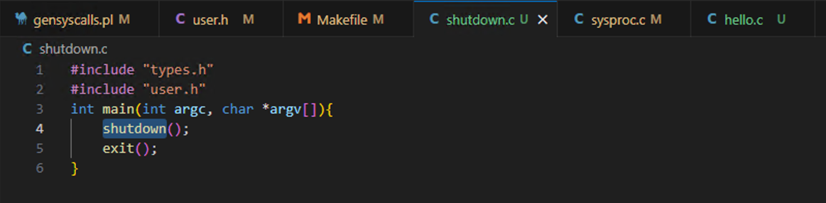

In sysproc.c I wrote the code to carry out this. According to the week 8 document the outw(0x604, 0x2000); command will shutdown the operating system running in Qemu:

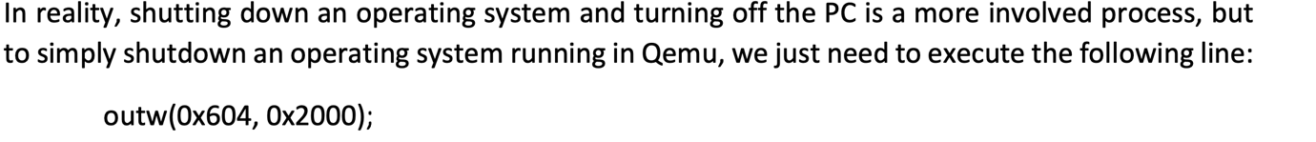

I made a new function called sys_shutdown in which I wrote the command to shut the operating system:

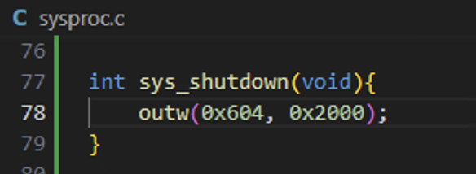

To test this I will run the program and enter shutdown and the program should shutdown as intended:

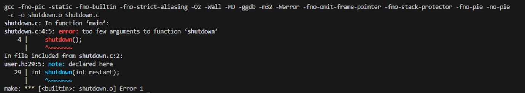

Test Failed – the program failed to build

To fix this error I entered the return 0 after the shutdown call because incase of the outw statement failing there has to a be a return so the program dosent break.

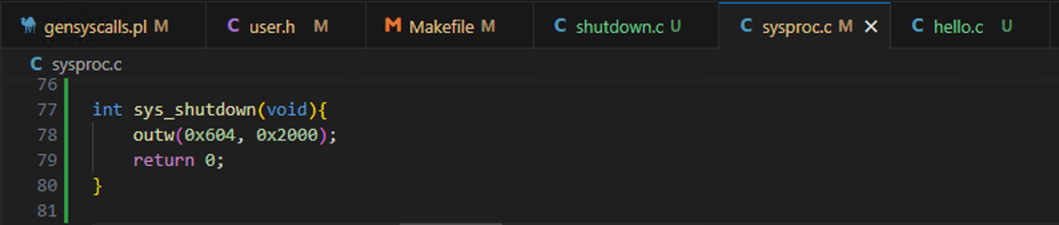

To test if this was working I ran the code and type in shutdown which should close the qemu system running and close:

Before pressing enter:

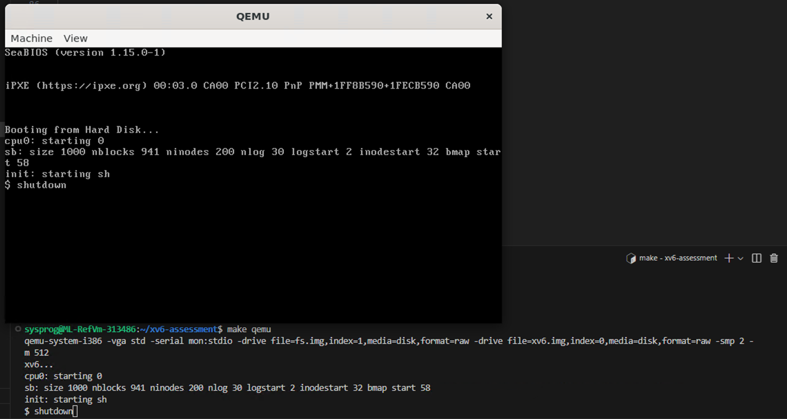

After pressing enter:

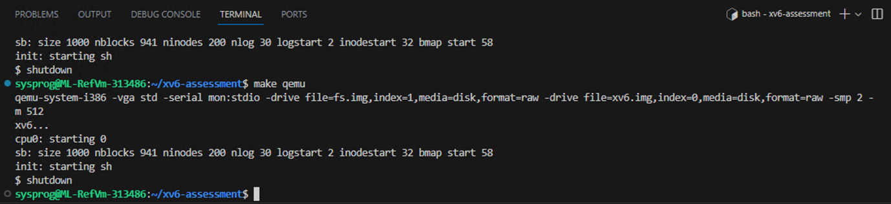

Test Passed

The next task was to add functionality to the shutdown function to take an input if in the input the user specifies they want to shutdown and restart the program should shutdown and then restart as asked. The first change was in user.h to tell the program that shutdown will take an input:

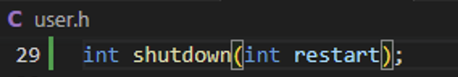

This following is the updated shutdown.c class. The class will first check if the user entered an argument after writing the shutdown call. If they have the system will check if the argument was “-r” if it was it will call the shutdown function with the value of 1. If not the system will call the shutdown function with the argument 0.

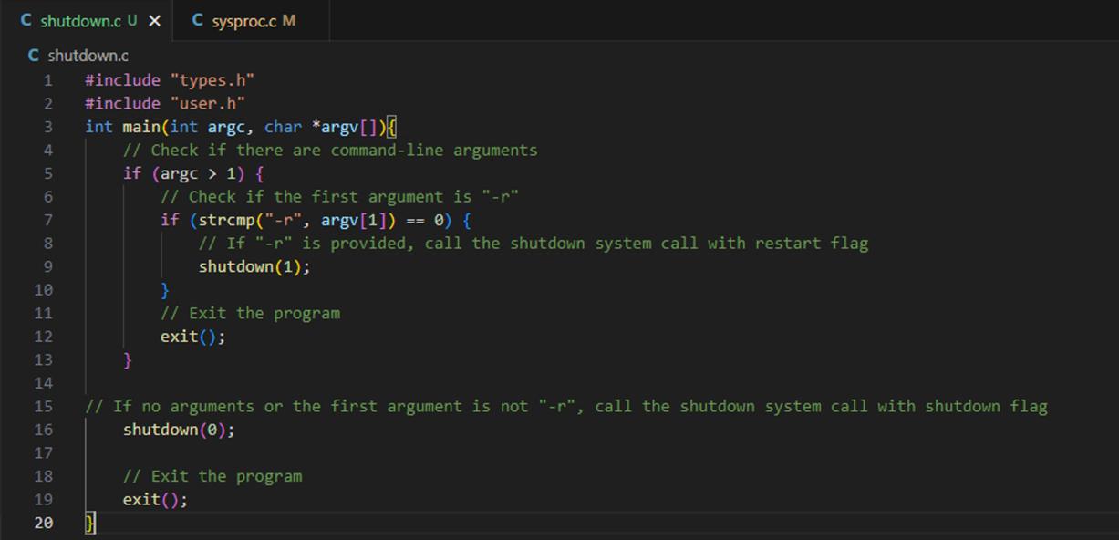

The following is the new sys_shutdown function. I first made a variable called user_input, which then gets the user input from the user-space and stores it in user_input which will be set to 1 if “-r” was inputted after the shutdown call. There is an if statement next which will check he input. If there is no input the system will just shutdown as it ddid before. If the user did input “-r” the user_input variable will be equal to 1 we then reestart the program using the following code which was provided by wayne:

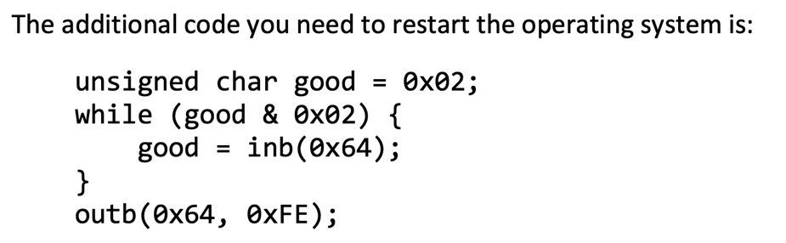

After which we put a return 0:

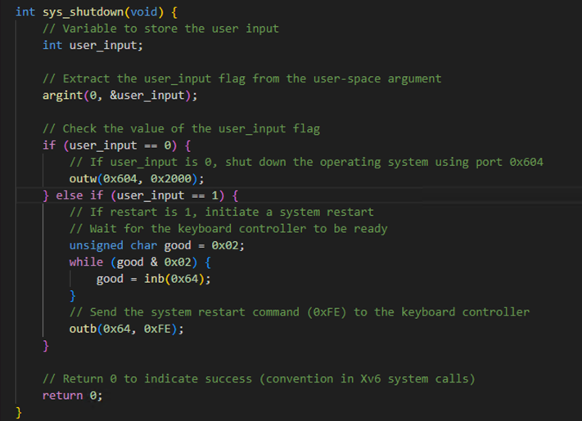

To test this I will run the code and enter shutdown first and the program should shutdown as intended:

Before pressing enter:

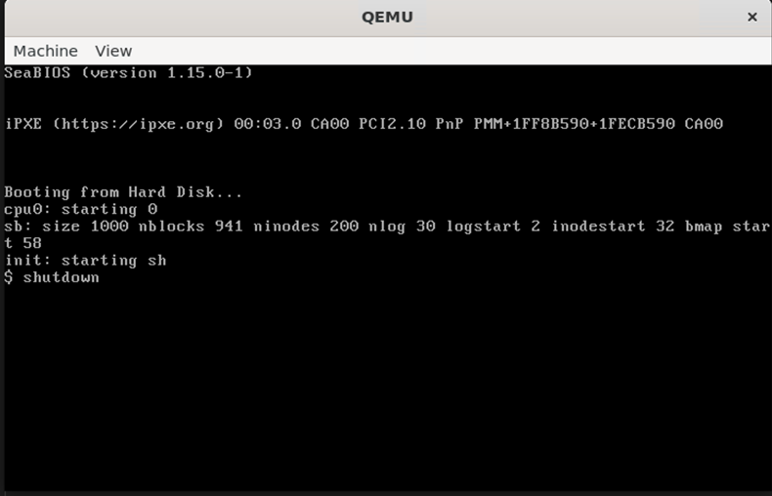

After pressing enter:

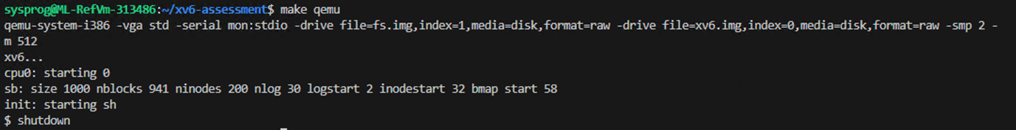

Test Passed

The next test I will enter shutdown -r which should restart the program:

Before pressing enter:

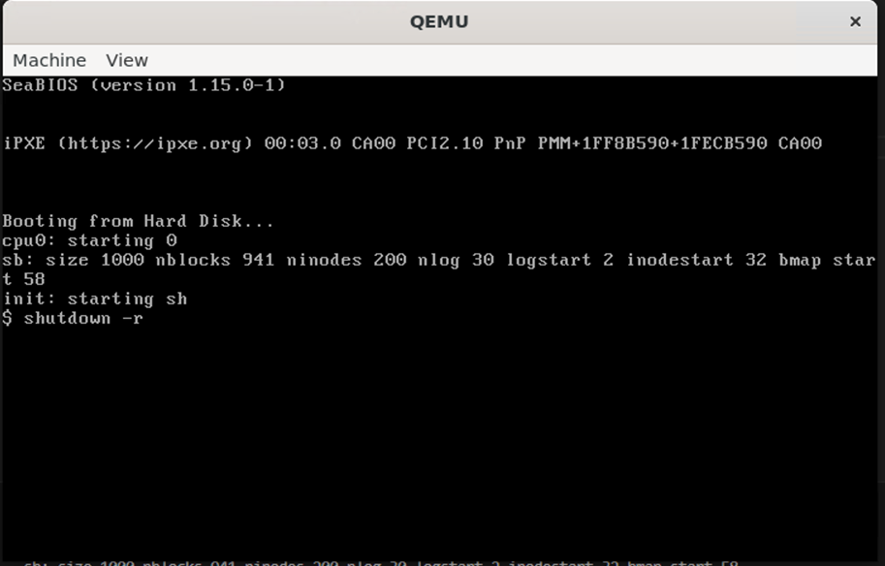

After pressing enter:

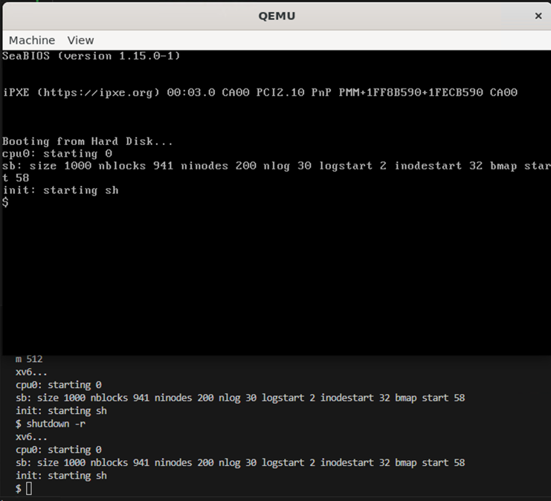

Test Passed – program successfully shutdown and restarted by itself.

Sunday 3rd December 2023: 11:55am – 5:25pm:

Now I got all of the week 8 tasks done and working I am ready to begin attempting the assignment. The first step before writing code was reading the information written about stage 1 in the assignment brief and how it should be attempted, I did this to make sure I understood what I was going to code. The first point of implementation was setting up the 0x13 video mode. To do this we need to set the starting memory address to 0xA0000, screen width to 320, screen height to 200 and the colour can be one of 256 colours for now we will use the white colour which is 15 for the pixels we draw:

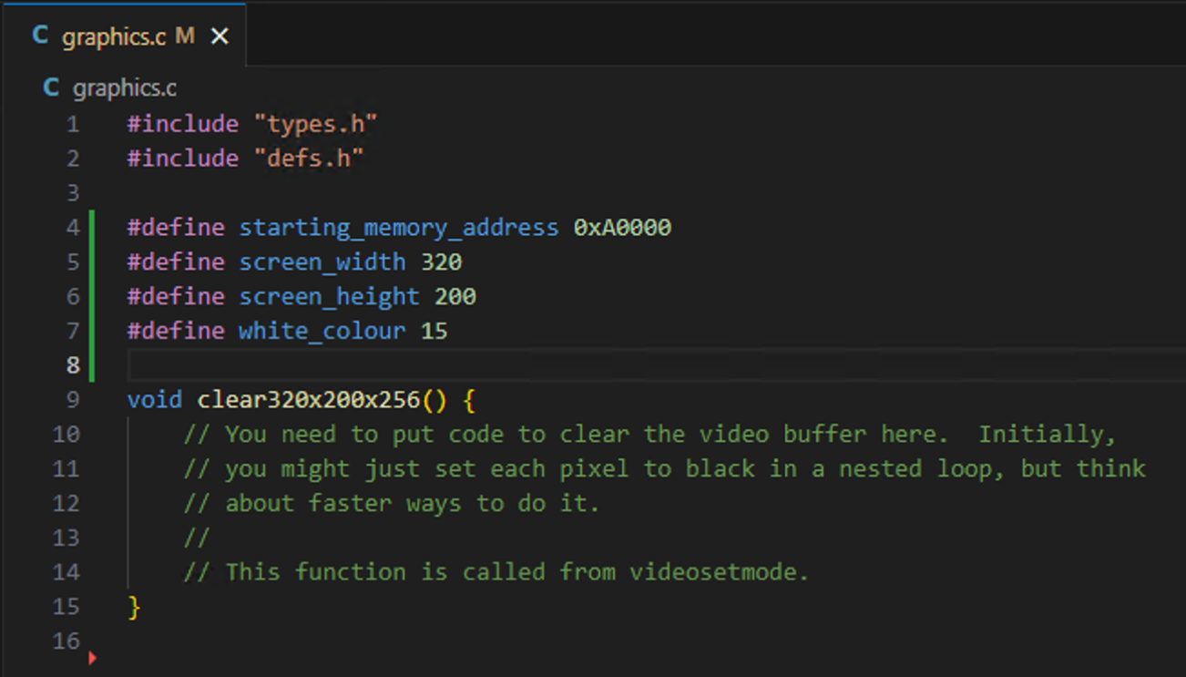

After this the next step according to the rubric is to add 3 new system calls “int setpixel(int hdc, int x, int y)” – which will set the pixel at the given co-ordinates to the colour white whch is what we are currently using. “int moveto(int hdc, int x, int y)” – this will tell the program the starting point from which we want to draw, if this is not set the default values will always be used which are 0,0. Final system call to add is “int lineto(int hdc, int x, int y)” – this will get the starting position of moveto and draw a line from it to the co-ordinates given in lineto:

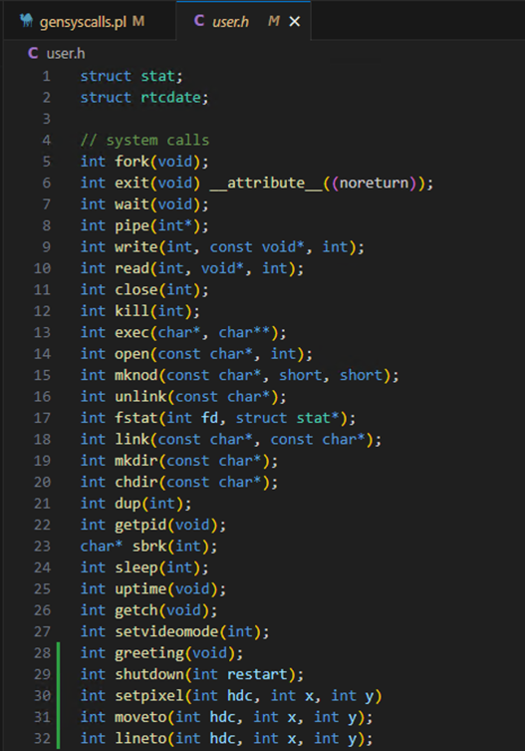

I then added the setpixel, moveto and lineto to gensyscalls.pl: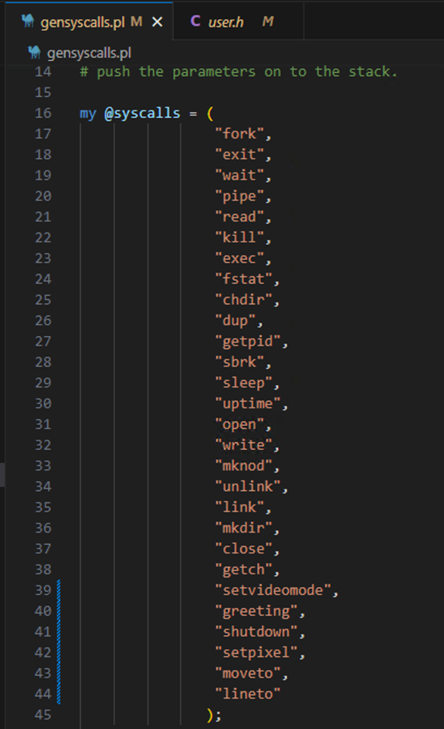

Now the rubric stated that I should search for suitable line drawing algorithms and recommended searching bresenham line drawing algorithm. After searching online and reading multiple articles I found the following Wikipedia article that has a indepth guide about besenhams line drawling algorithm: <https://en.wikipedia.org/wiki/Bresenham%27s_line_algorithm>. First I started working on writing the void clear320x200x256() this was the psudo code provided:\ 

The following is the code I wrote for this. I first included the memlayout.h file because it contained information about the kernel and the addresses I will require to draw:

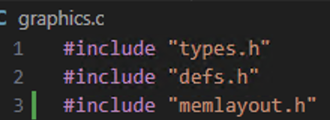

I then created a helper function that will convert physical memory I give to the equivalent virtual memory and return it. This function I made is a static uchar* meaning that it is only visible to this file and will return a unsigned character which is pointing to the virtual memory location: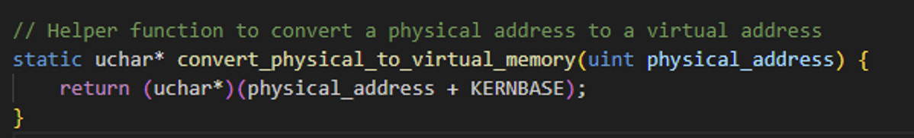

The following is the clear320x200x256() function. This first takes the starting_memory_address variable that I defined earlier with the value of 0xA0000 calls the conver_physical_to_virtual_memory function created above and assigns the virtual memory to the video_memory_address variable. We then calculate the total number of pixels on the screen displayed before the user by multiplying the screens width to the screens height and save it to the total_number_of_pixels variable. Finally I loop through all the pixels one by one and set them to be black meaning the background will be black:

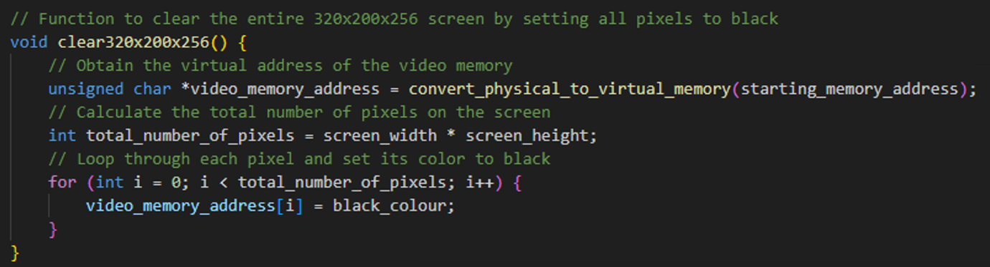

The black colour variable is the following:

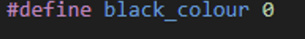

Which I obtained by reading the rubric where it gives 15 colours and their value:

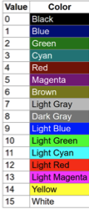

To test to see if this works I made a new file called stage1test.c which I copied the following code in from the rubric:

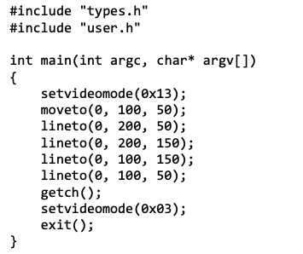

But since I have not implemented moveto, lineto and setpixel yet I commented those lines and just left the following:

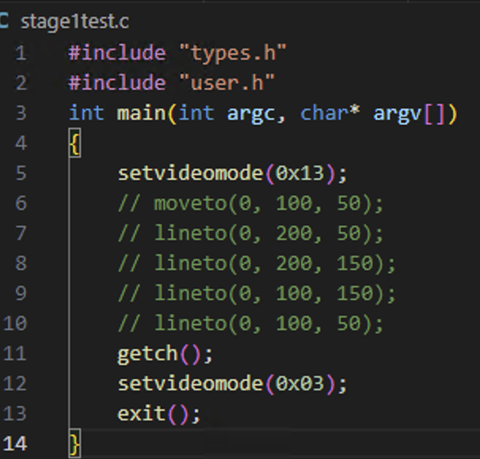

I also added stage1test to the makefile UProcs so it can be called:

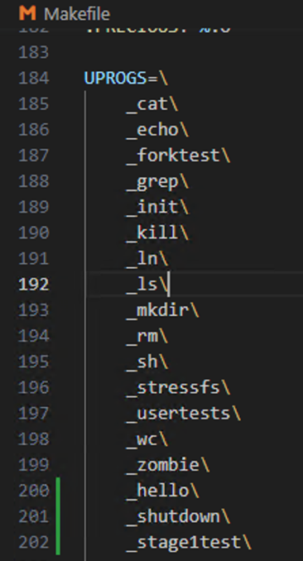

To test if the screen is generating a 320x200 black screen as coded I will run the code and type stage1test which should display it as expected.

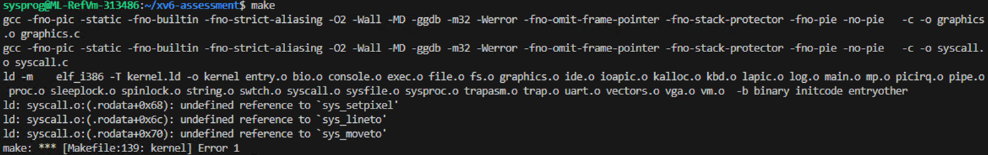

Test failed

Which after reading the message was because I declared 3 new system calls but haven’t implemented them yet so for the time being I removed them since for the time being:

Before:

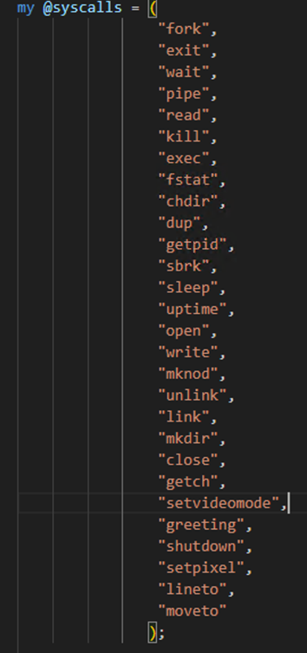

After:

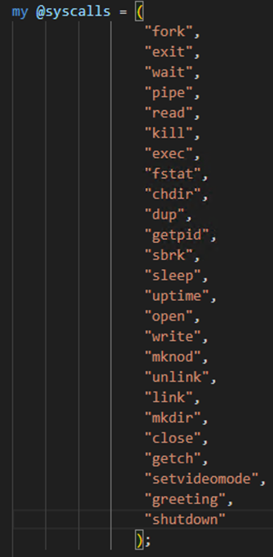

Now to test whether this solved the issue I will run make again and it should compile without any errors:

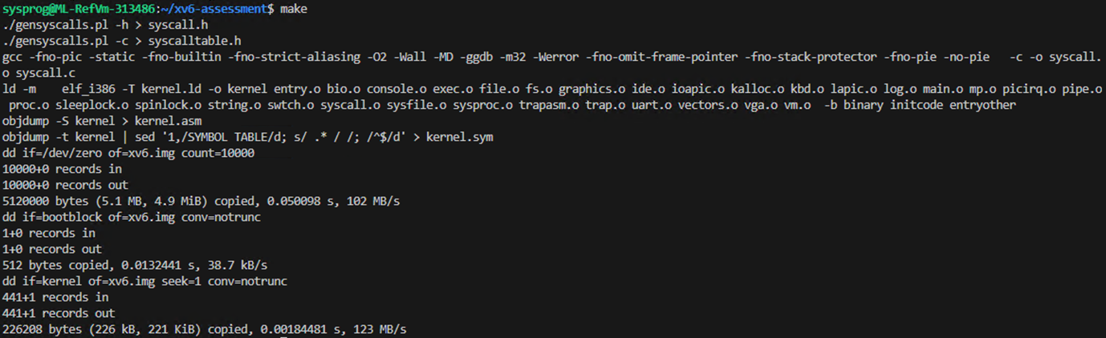

Test Passed

The next test will be to run a make qemu and it should compile and load the qemu window:

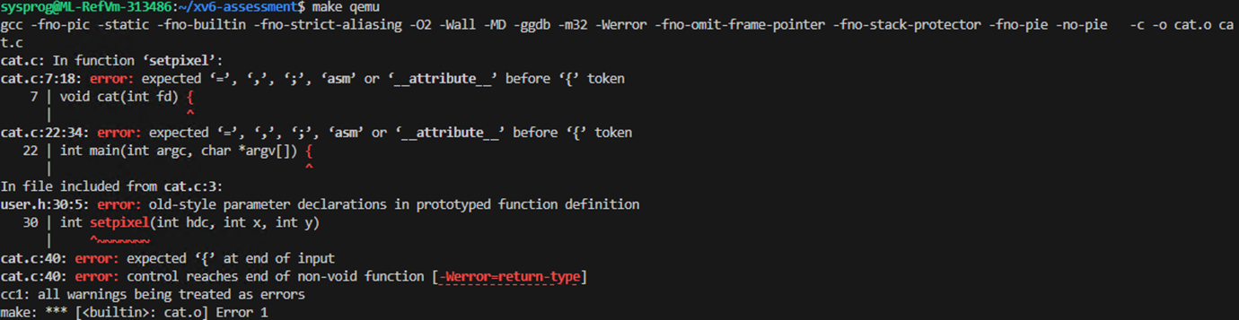

Test Failed

After looking through my code I realised the mistake I made was in user.h when declaring setpixel I forgot to add a semi colon on the end:

Before:

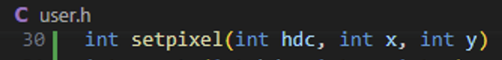

After:

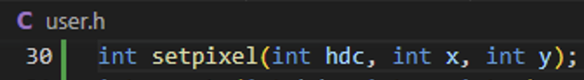

Now I will run make qemu again to test if the program compiles:

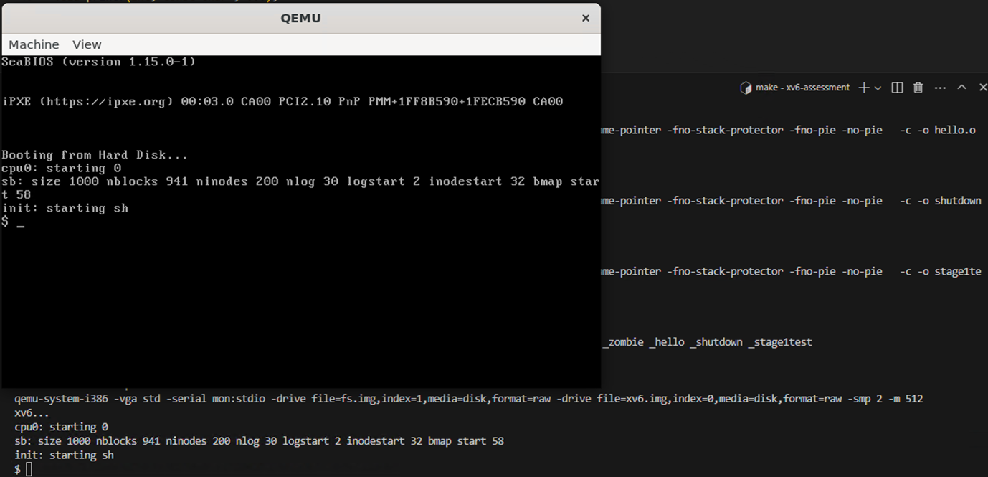

Test Passed

The next test will be to enter the stage1test and it should display a new black 320x200 window:

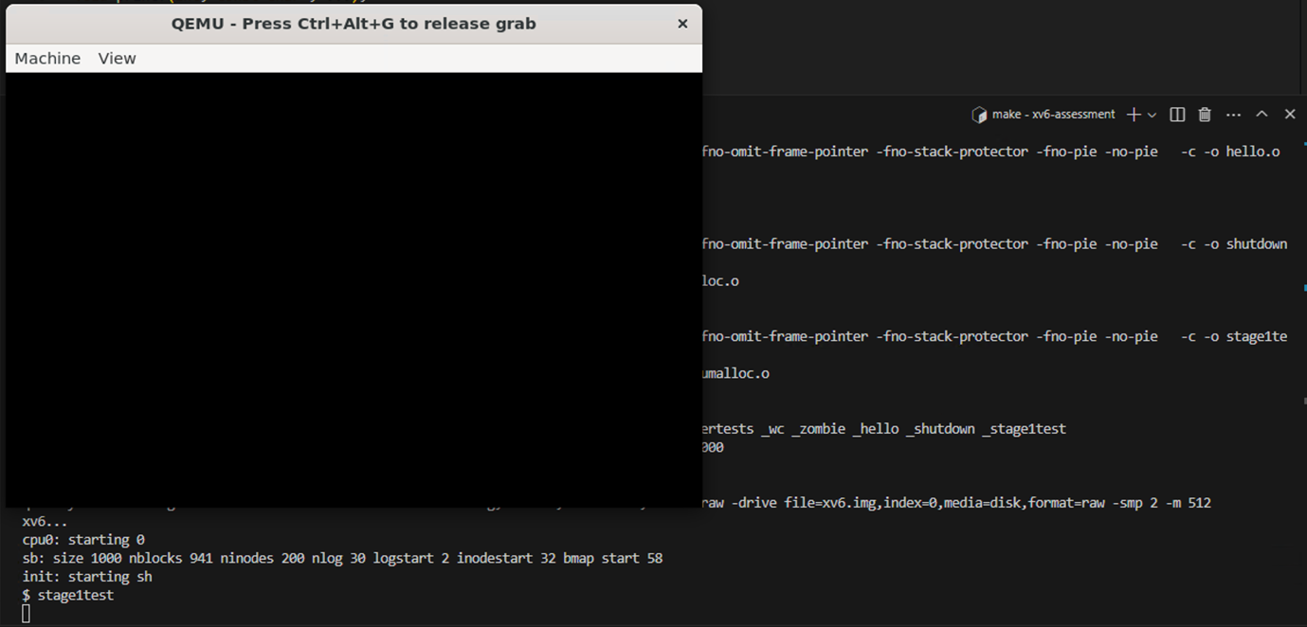

Test Passed

Now I have the code for generating a 320x200 black window. Now I wrote code for setpixel, I first created the sys_setpixel(void) in graphics.c before when writing helloworld I created it in sysproc.c but Wayne said he wanted all the main code to be in graphics.c so I will write that code here. The code for setpixel is basically the same as the clear320x200x256 function but that function is colouring the whole screen I just need to edit it to just work with the pixel given when called. The following is the code and this is the explaination. I first created 3 new integer variables that will hold and are called hdc, x and y. Then I use the argint function to get the hdc, x and y from the system call and store them in my hdc, x and y variable. I know this function from the last task of week 8 where we used it to retrieve the user input. I then have an if statement that makes sure both x and y and larger than 0 and either equal or smaller than the screens width and height of 320 and 200. This is done to make sure the pixel being drawn is there on the screen for the user to see if not we will return an error code of -1 as stated in the rubric to do. If the if statement is passed I will then make a similar variable called video_memory_Address that converts the start_memory_address from physical to virtual memory. We will then work out the linear offset of the corresponding values of the given x and y in the video memory by doing the following equation: y * screen_width + x and assign iit to the variable linear_offset. Finally I will get the video_memory_address and point to the linear offset I calculated and tell it to colour that pixel white:

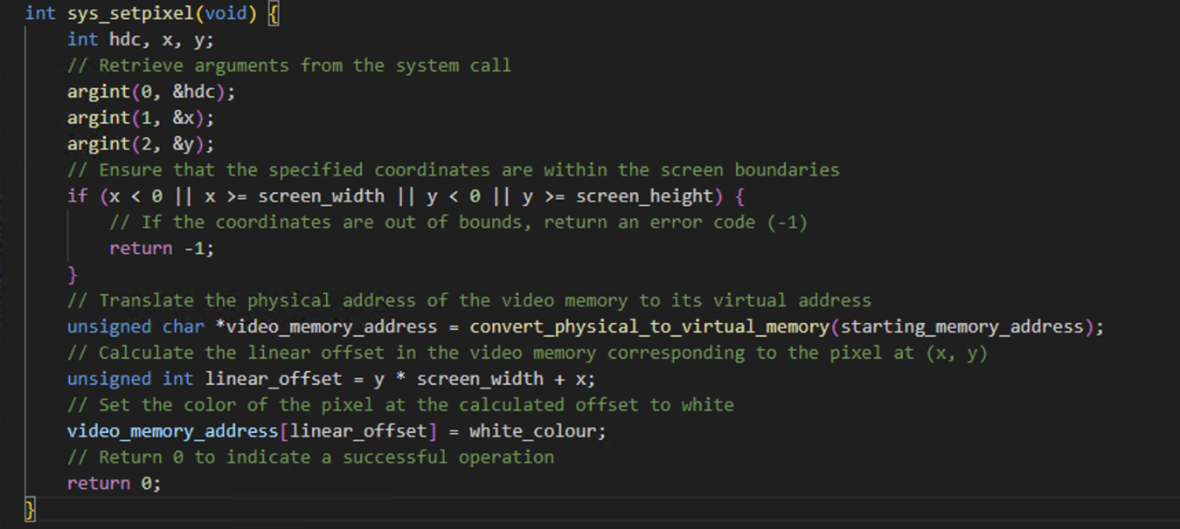

I also must add setpixel back to syscalls since I removed it earlier when testing to see if a 320x200 black window was generated:

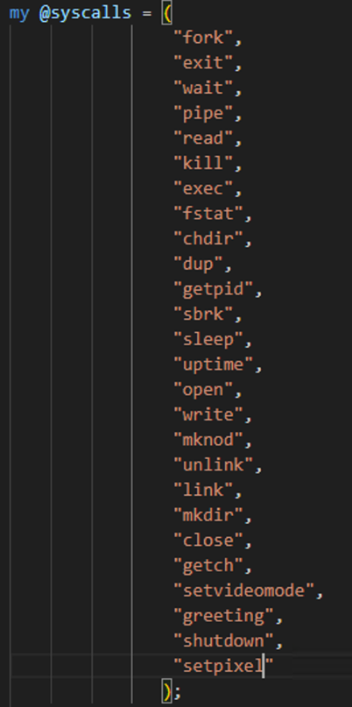

To test this I made the following changes to stage1test to test if setpixel is working:

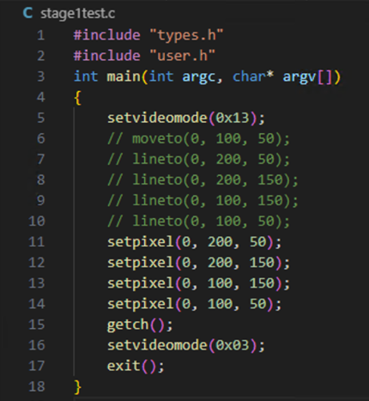

Now I will run the program and enter stage1test to test if setpixel is working it should display 2 white pixels on the window:

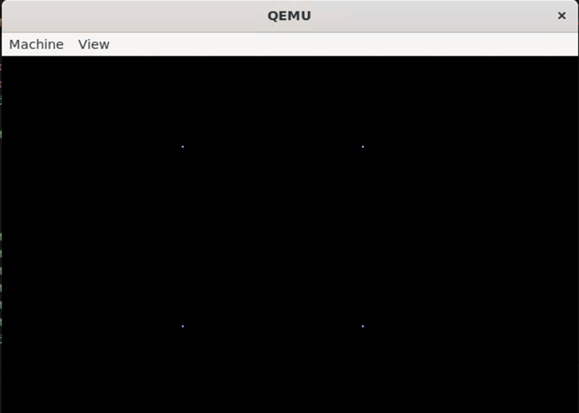

Test Passed

Tuesday 5th December 2023 – 1:00pm – 3:00pm:

Today I was going to go ahead to implement the moveto function which will be used to give the initial co-ordinate I want to start drawing from followed by the lineto. To do this I first needed to put moveto back into system calls:

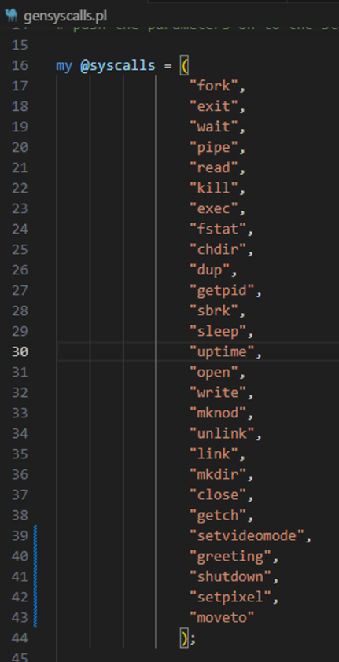

I then went into graphics.c where I created 2 new variables that will store the x and y location of initial co-ordinates given called current_x_coordinates and current_y_coordinates:

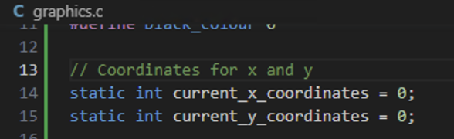

Then I declares the int sys_moveto(void) function in graphics.c. this function will be the same as setpixel but the main difference will be I wont be drawing any pixels Ill just get the co-ordinates given and store them in the 2 variables of current_x_coordinates and current_y_coordinates. When the function starts I will declare the hdc, x and y variables and get the user input for each and store them in the corresponding variables. After which I will run 4 checks on the x and y variables to see if x and y are larger than 0 and smaller than the width and height of the screen. If the checks are passed I will then assign the x and y to the 2 current_x_coordinates and current_y_coordinates and return 0: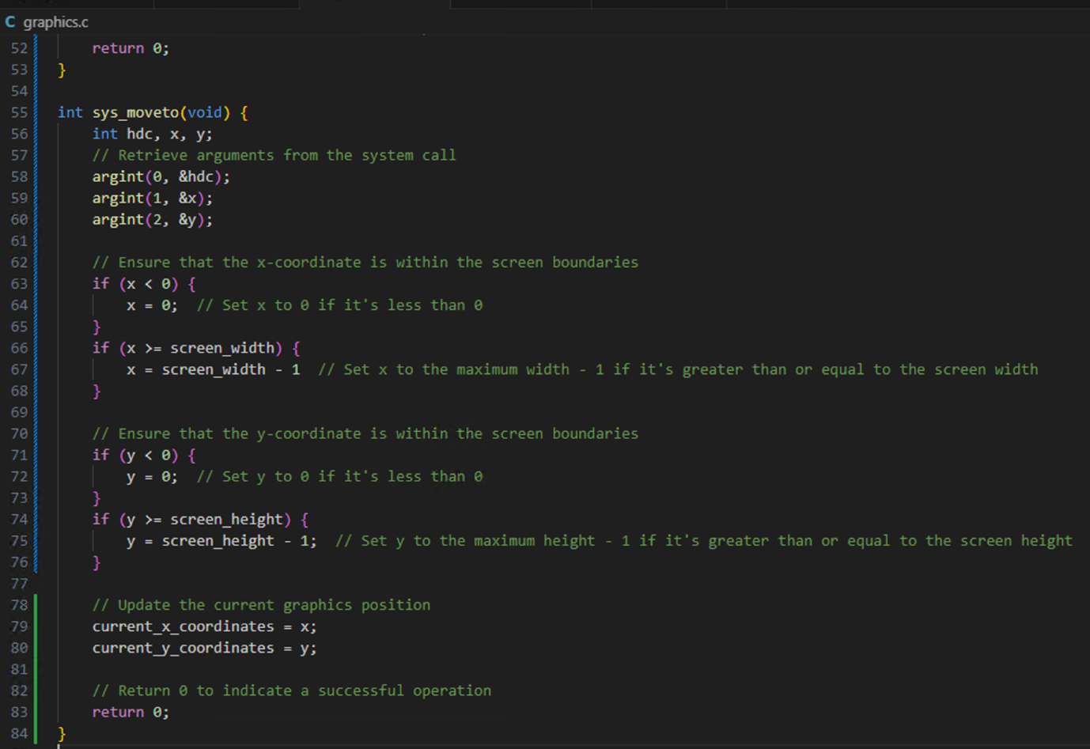

To test whether the move to is working I added the following line in stage1test.c:

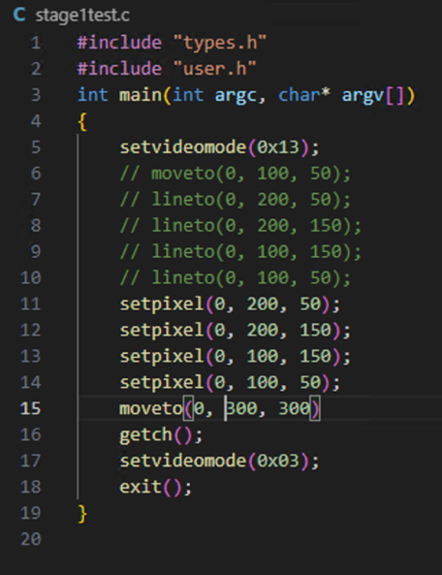

Now I got the tests updated I will compile the program first doing a make clean then a make then make qemu and enter stage1test which should compile and print the setpixel on the screen without any errors if there are errors it means the moveto has an issue since the rest worked fine before:

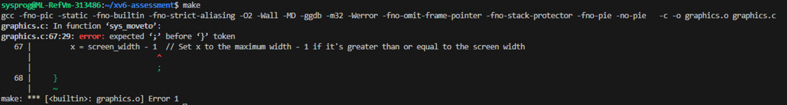

Test Failed

After running make I got the error above which was because I forgot a ; in the following this is the fix:

Before:

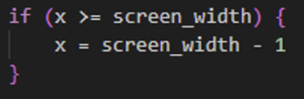

After:

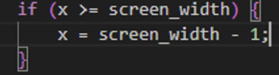

Now when I will test to make sure this solves the issue by running a make and it should compile without errors:

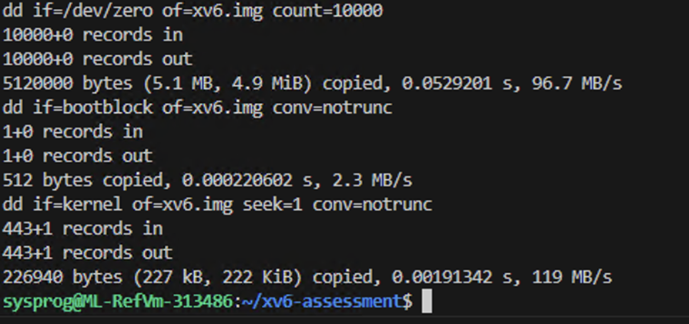

Test Passed

The next test will be to run a make qemu and enter “stage1test” and if successful should load and display all 4 pixels without an error:

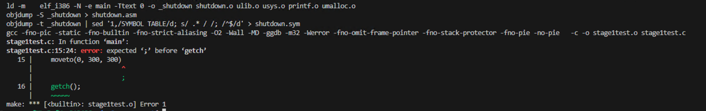

Test Failed

I made a similar error to the one above and forgot to add a semi colon on the end when adding move to, here is the fix:

Before:

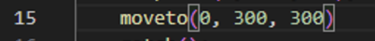

After:

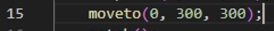

Now I will run a make qemu again and it should compile correctly:

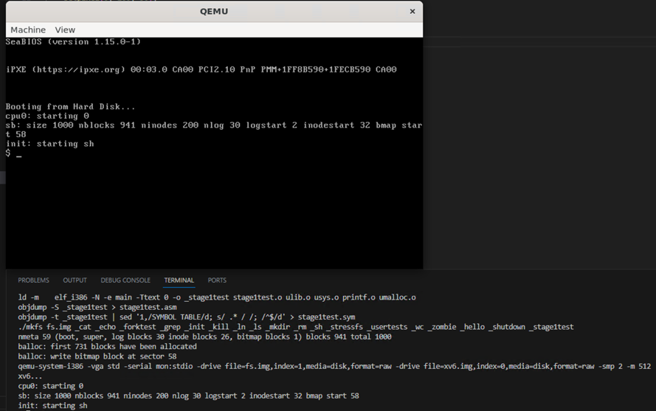

Test Passed

Now I will enter stage1test and it should compile without errors to show moveto is working:

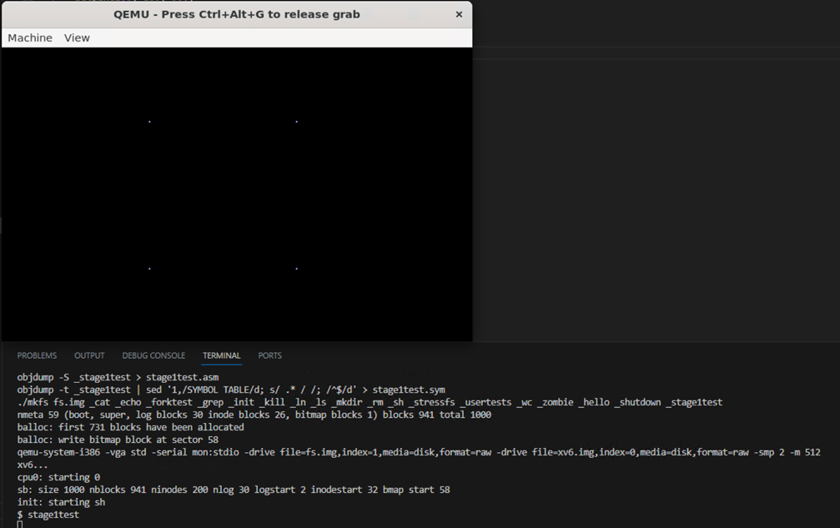

Test Passed

Thursday 7th December 2023 – 11:24 am – 5:14pm:

Now I have moveto and pixelto working all I need is lineto and that will be stage 1 completed. First step I did was adding lineto to the systems calls:

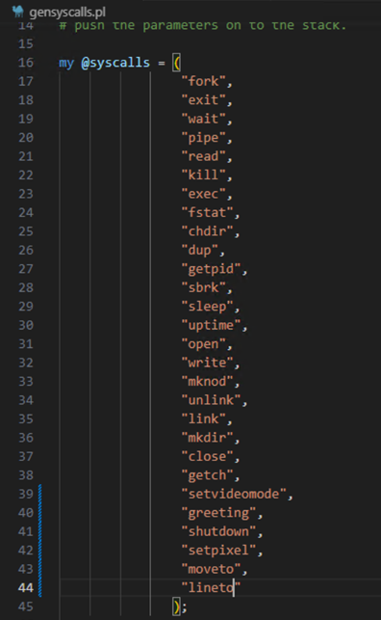

When writing the lineto code I will have to refer to the previous Wikipedia document that I found with bresanhams line algorithm: <https://en.wikipedia.org/wiki/Bresenham%27s_line_algorithm>. Which gives the pseudo code for the line algorithm I will be implementing:

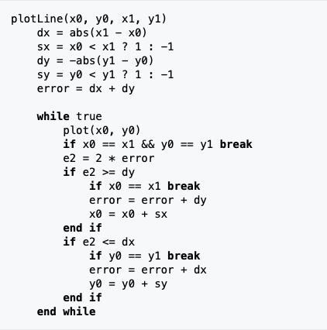

The following is my interpretation and implementation of the algorithm:

Before writing the code there was one function that I was unsure about which was the abs function after some research I figured out what it did from the following article: <https://www.geeksforgeeks.org/program-to-find-absolute-value-of-a-given-number/>. Which is to return the absolute value of the number given the following is my implementation of it. The function takes a value checks if the value is negative if it is it will return the same number but positive, if the value was positive it will just return the value:

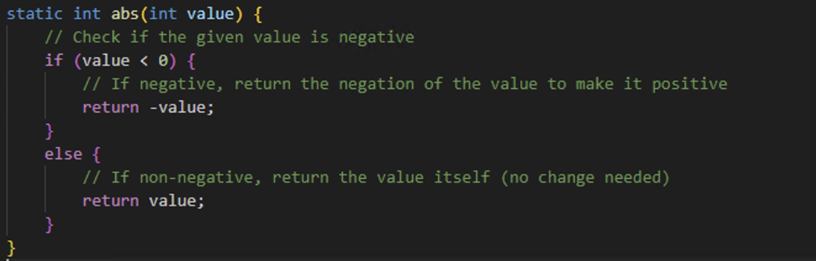

The following is my interpretation of the bresenhams line algorithm. I first create 3 new variables hdc, x1, y1 and assign them the arguments gained from the system call. I then assign x0 and y0 the current x and y coordinates inside the variables. I subtract x1 from x0 and y1 from y0 and utilise abs to get the absolute value of each subtraction and save them to dx and dy. I then determine the sign of the x and y directions by checking if x1 and y1 are larger than x0 and y0 if they are they get assigned 1 if not they will be 0 and the result is stored in sc and sy. I then make an error variable that contains the sum of dx and dy and I also make a e2 variable. Then I fo into a while loop where we make sure the coordinates inside x0 and y0 are first within the screen bounds if they are we will draw them to the screen in the colour white. After this is done the next if statement chekcs if x0 and y0 are equal x1 and y1 if they are equal we break out the loop. We multiply the value in the error by 2 and assign it to e2. If e2 is larger or equal that dy or dx we will update the error item by adding the variable that is equal with dy or dx. We also update x0 or y0 with their corresponding sx or sy. This is where the true loop ends we break out and add the x1 and y1 coordinates to current x and y coordinate variable and return out the funciton:

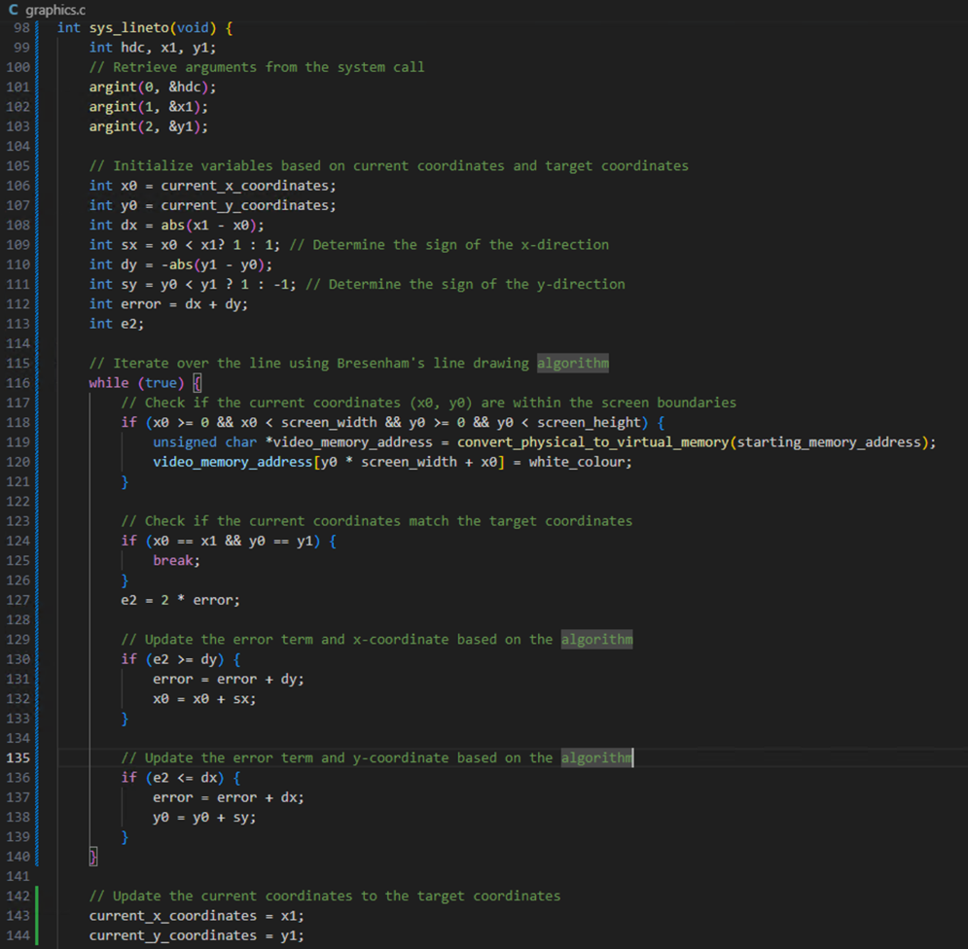

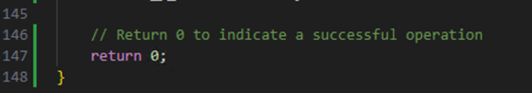

Next I updated the stage1test by removing the set pixels I have added and move to and just leaving the test code from the rubric:

Before:

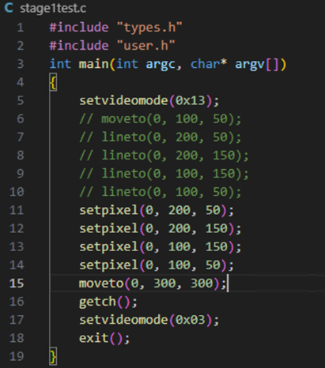

After:

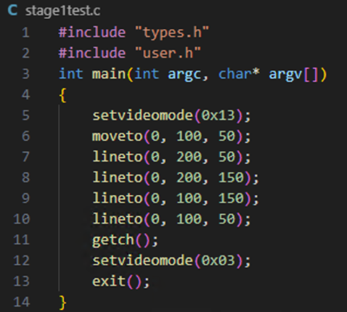

Now to test if the code works I will first run a make and it should build successfully:

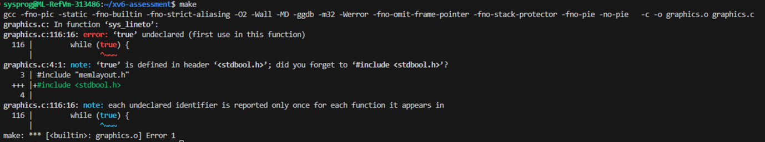

Test Failed

I forgot to include the “stdbool.h” library since I am using the while true heres the fix:

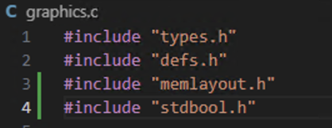

Now when I will test this fixed the issue by running make and it should build without error:

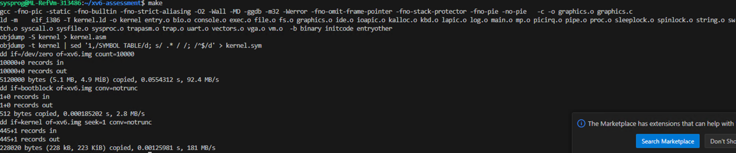

Test Passed

Now the next test will be to run make qemu and it should build successfully aswell:

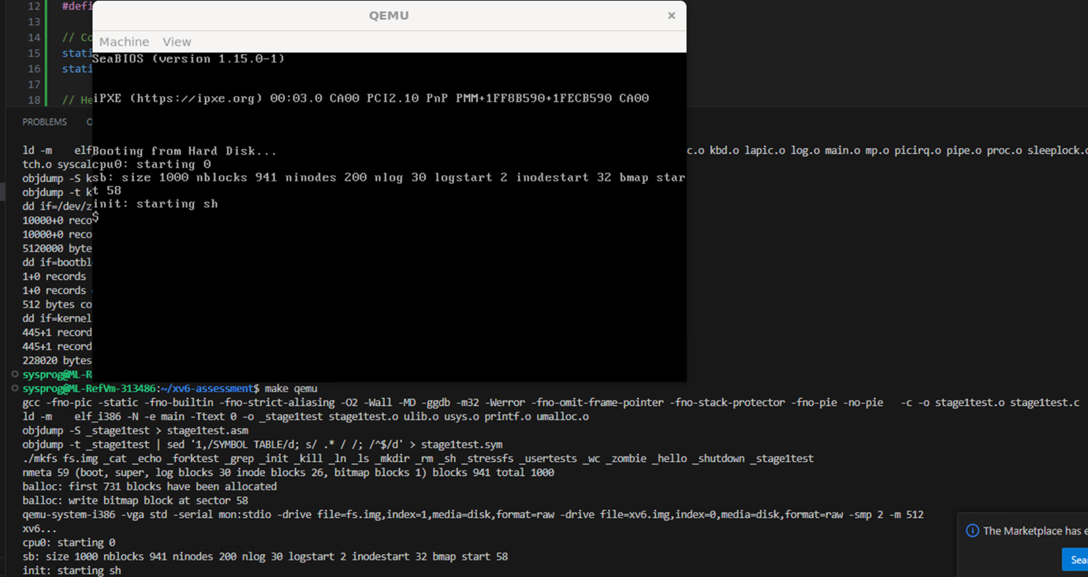

Test Passed

Now I will run stage1test and it should display a square if it has I have written the algorithm correctly:

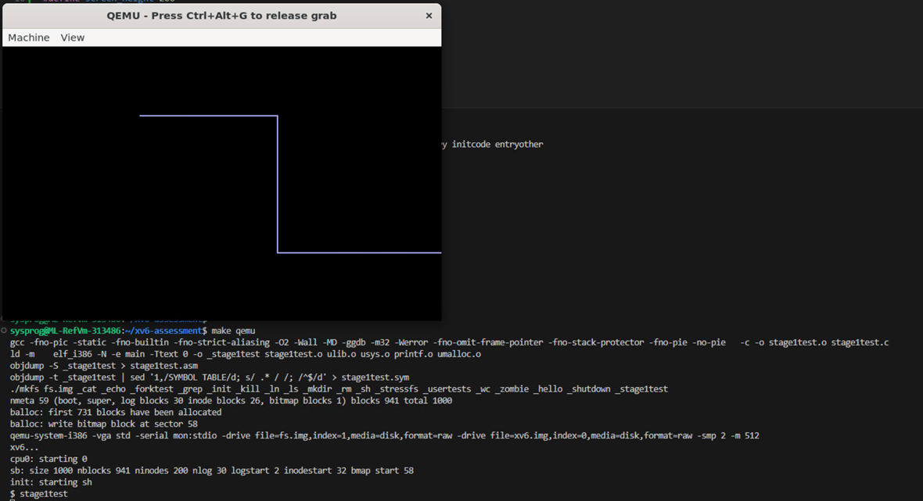

Test Failed

I have gone wrong in the code somewhere since the lines drawn are incorrect it is supposed to draw a square but after the lineto(0,100,150) went the wrong direction. After revieweing my code and comparing it with the pseudo code I figured out the mistake I forgot to write that is x1 is not larger than x0 it should return -1 but I have 1 currently:

Before:



After:



Now to test if this solved the issue I will run make qemu and enter stage1test and it should display a square:

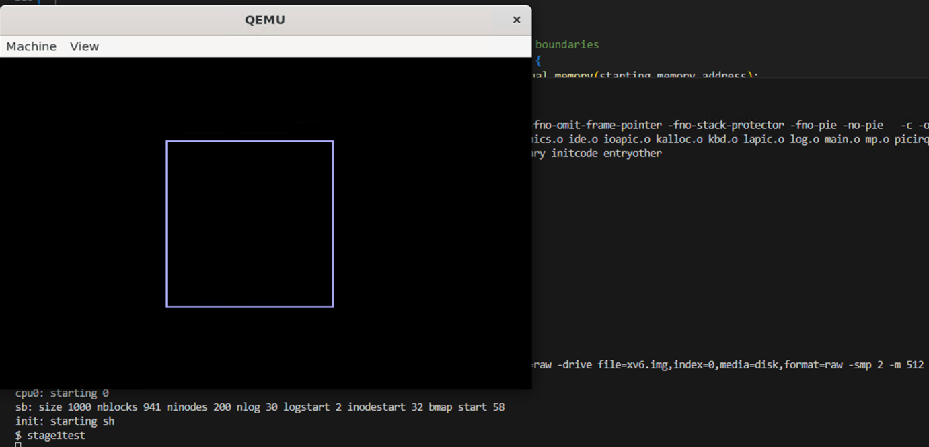

Test Passed

That is stage 1 completed.

Saturday 9th December 2023 – 12:35pm – 3:24pm:

Today I will start working to implement stage 2 now that stage 1 has been completed. After reading the rubric I will need to implement 2 new system calls int setpencolour and int selectpen. First I will start by implementing setpencolour. I first wrote this is User.h: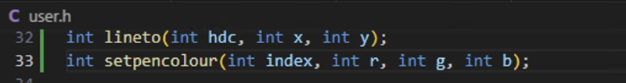

Also added it to systemcalls in gensyscalls.pl:

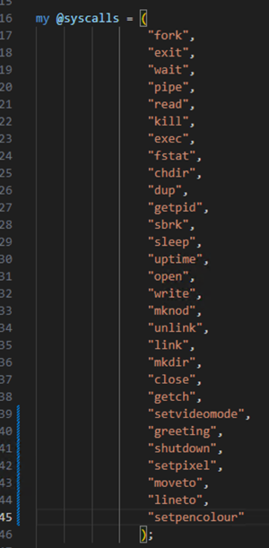

In the graphics.c I declared a new function called int sys_setpencolour(void) which declares 3 new variables inside it index, r, g and b. this will store the index, r = red, g = green, b = blue. I then use system calls to retrieve the argument and add it to the variables made. I then run 8 if statements that check to make sure the index is between 16 – 255 and rgb are between 0-63 as the rubric states:

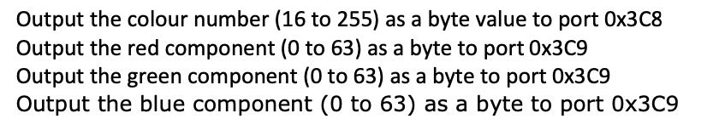

If the index is not between 16-255 I will return a value of -1 and if the rgb values are not between 0-63 if its below 0 I will clip it at 0 and above 63 will be clipped at 63. After which I outb all the values to the specified ports in the rubric. outb is a c function that allows you to enter a port and a value to push to it which I found out from this website: https://man7.org/linux/man-pages/man2/outb.2.html. Finally return 0 to end the function.

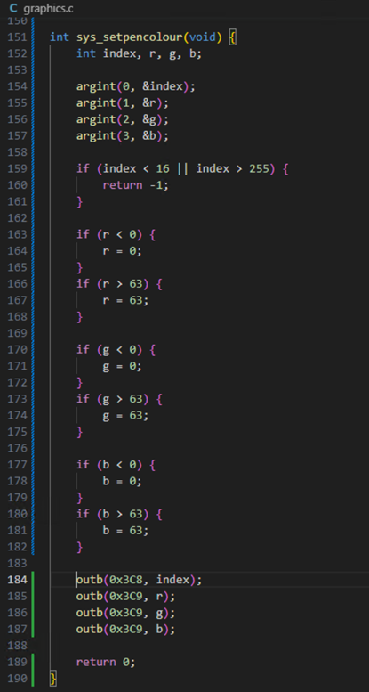

The following is the outb function that I wrote using the following articles: <https://forum.osdev.org/viewtopic.php?t=25301>. The function takes in the port that is the intended destination and the value that is intended for it. The asm violate is a inline assembly mechanism that allows the inclusion of assembly language code directly into C. we use this to directly place the value and port in their destinations:

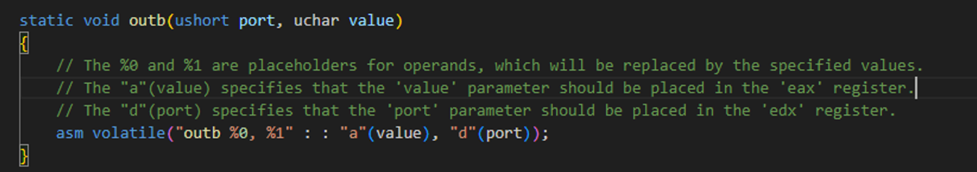

Since this is stage 2 I made a new file to test the code in here called stage2test:

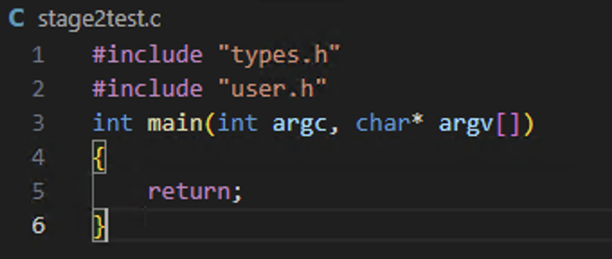

I also added the file to the UPROGS calls so it can be called by the user in make qemu.

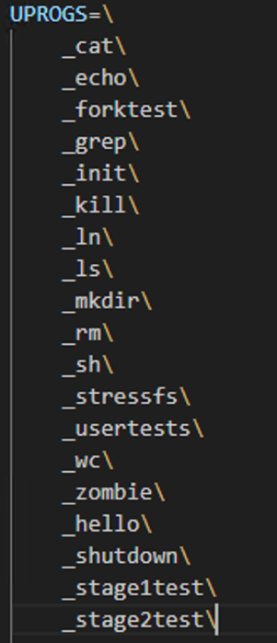

I was unsure how to test if this function was working or not. So I decided to move on and go about creating the next function and if the selectpen is coded correctly when I set pen colour I will have to use it when utilising setpen.

Sunday 10th December 2023 – 2:55pm – 6:45pm:

Today I will work on implementing the selectpen function. Writing this function was straight forward as it just required me to sit down and turn the pseudo code into writing. The following was the pseudo code given in the rubric:

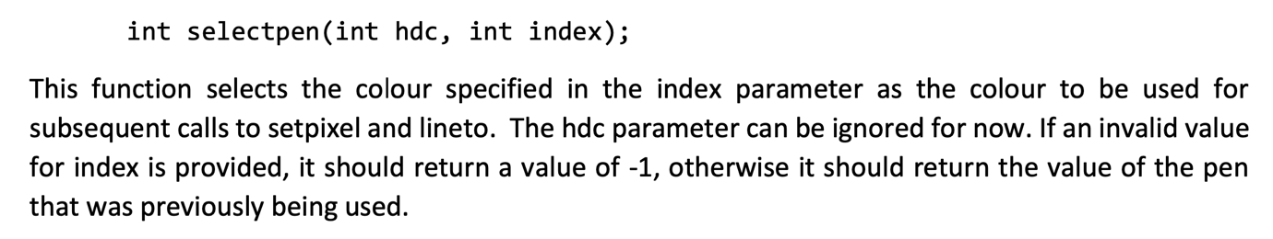

The following is the code that I wrote to implement this:

I first made a new integer that will store the pen colour chosen by the user. Whether its 1,2,3 ect.

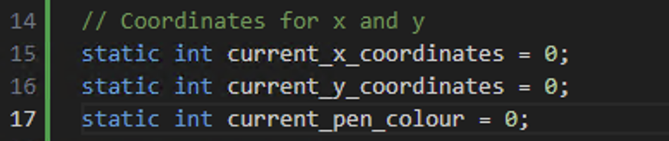

I added select pen to the gensyscalls:

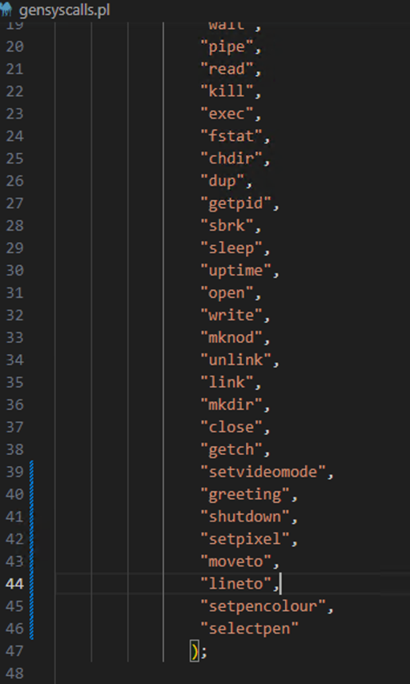

I then added setpen colour definition to User.h:

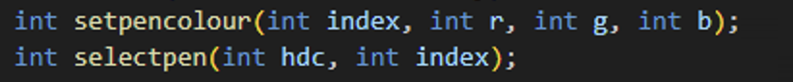

The following is the code for the selectpen that I wrote. I will first made variables for hdc and index and get the arguments from systems call and assign them to the correct variable. Then we check the index range is between 16 to 255 since that’s what it states in the rubric. I assign the current_pen_colour to index gained from system calls if it passes the checks. Finally I will return 0 to indicate we have finished successfully.

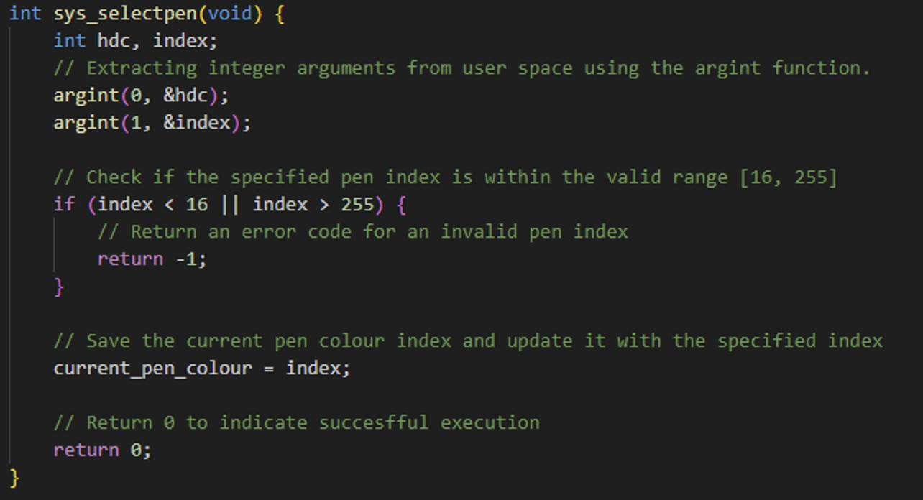

To test this I made a new file called stage2test.c which I will enter the same code to draw a circle but I will also add the two new functions to selectpencolour and selectpen: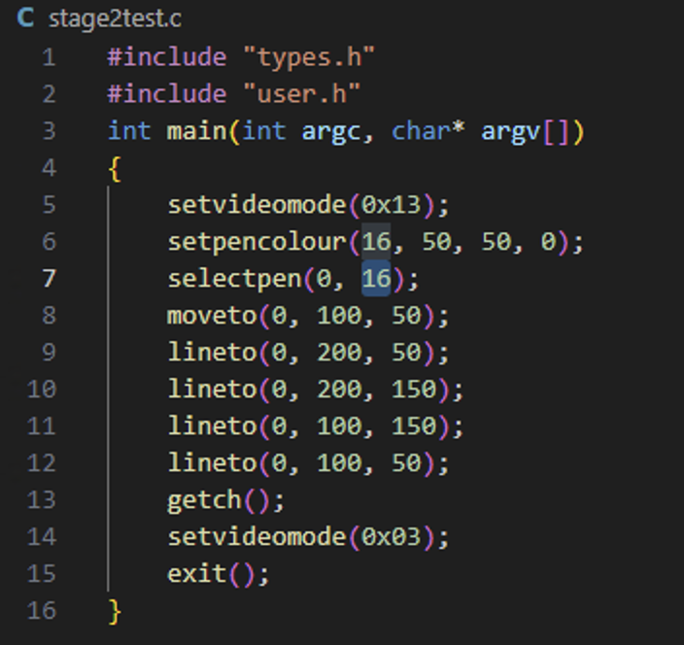

Added to Makefile:

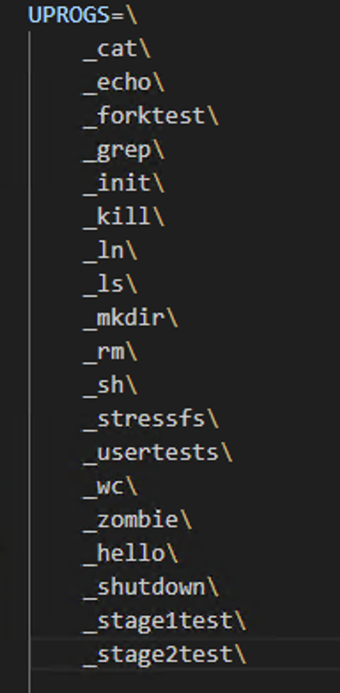

Now I will run the test and I will do this by building a make clean, make, make qemu and enter stage2test which should display a yellow square:

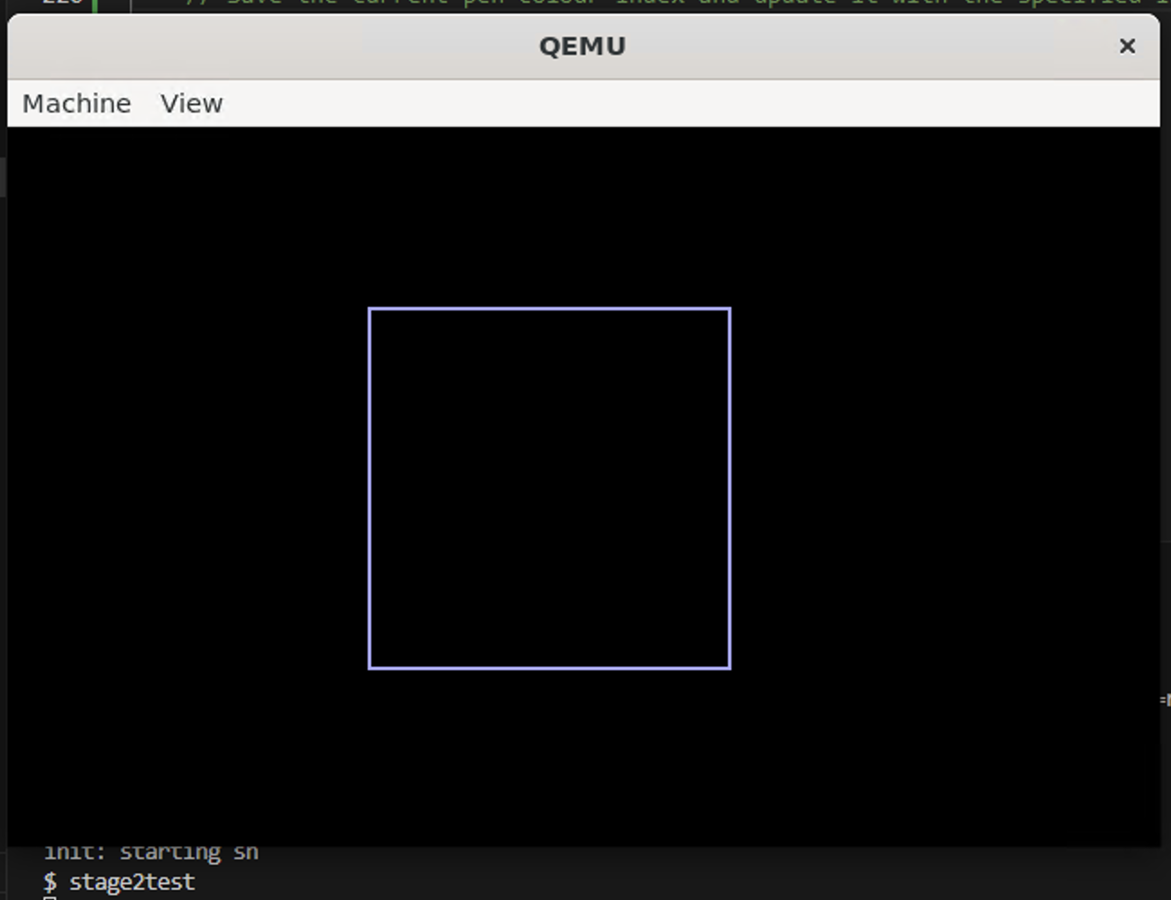

Test Failed

The program is outputting the white colour when we should be returning yellow. When revieweing my code I managed to pinpoint my mistake. In lineto when assigning the colour for the line previously I had it hard coded to white hence it displaying white. So I changed the white_colour to current_pen_colour which stores the index of the new colour entered above.

Before Change:

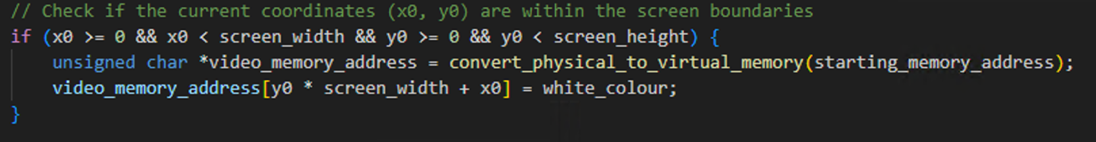

After Change: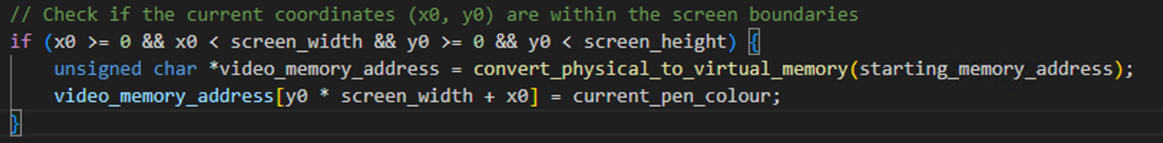

Now I will test to see if this fixed the issue of the square not colouring yellow. I will run the program and enter stage2test and it should display a square coloured yellow

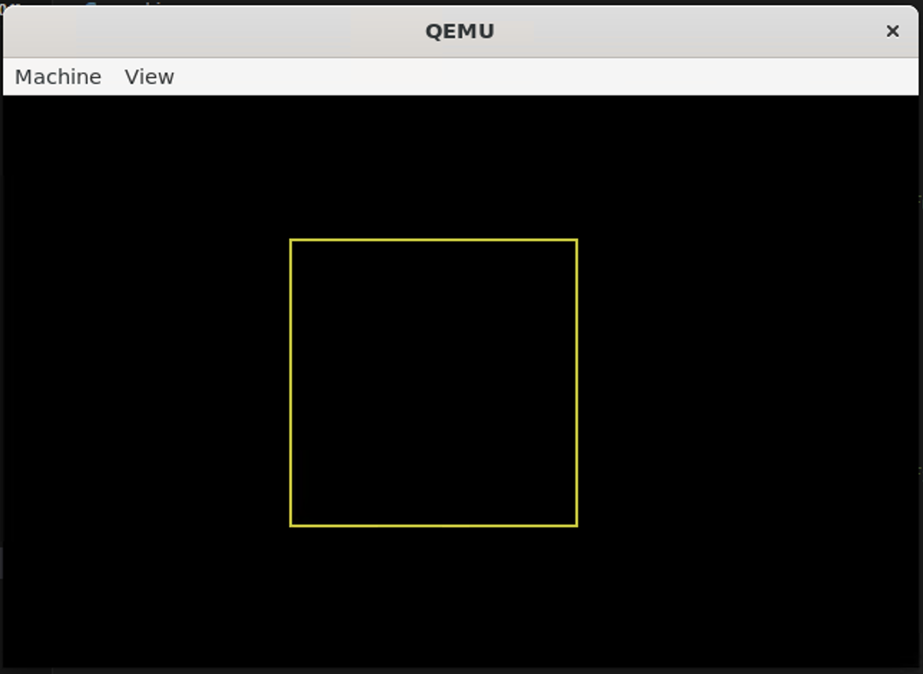

Test Passed

Now I have both functions working and tested to make sure I will start working on the next function outlined in the rubric to create which is the int fillrect(int hdc, struct rect * rect); heres the function getting declared and ready to use:

User.h:

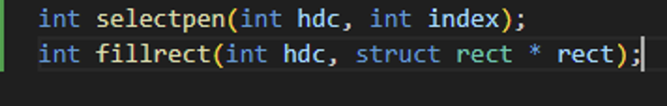

Gensyscalls.pl:

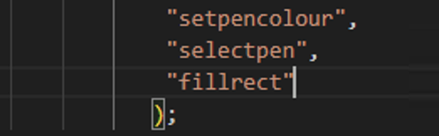

Graphics.c

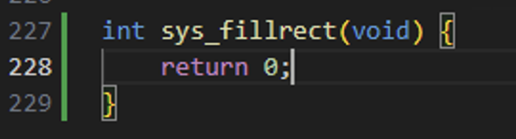

To fill the rectangle the rubric states I will need to make a structure for the rectangle that we can point at when filling in the rectangles. To do this I made a new file called rect.h with the code for the struct from the rubric in it:  
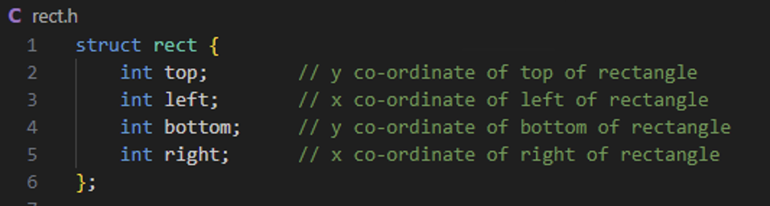

I then call this struct in the graphics.c file:

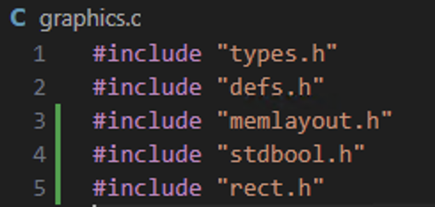

The following is the code that I wrote for the sys_fillrect function. Once the function starts I create 2 variables hdc and rect *r, I add hdc input to the variable and use argptr is used to retrieve a pointer to a struct rect from the second argument. If there’s an issue in getting the pointer it will return a -1 to signal an error. I then have a few if statements that make sure the rectangle to be drawn are coordinates for the screen if not they are clipped to the screen. I then check to make sure the rectangle is not invalid if it is return -1 to indicate an error occurred. I then get the starting memory address and convert it to virtual memory. I then loop though each pixel within the rectangle and set the colour of the pixel to the pen colour:

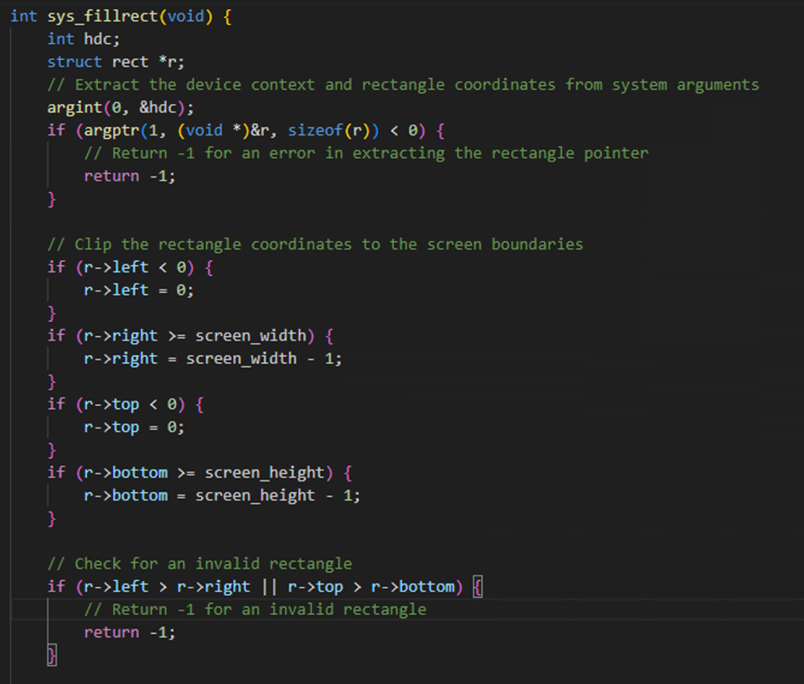

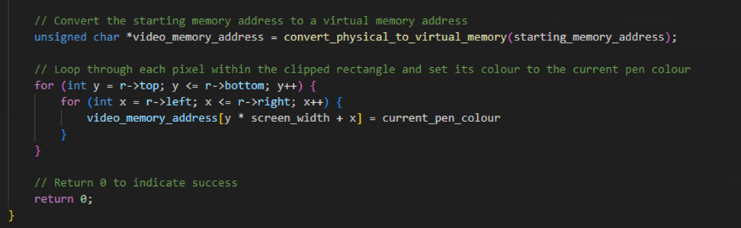

To test this I wrote a new UPROG call called stage2lrectfill.c that when called will aim to generate a rectangle that is filled in with colour. The code setsvideo mode to 0x13, then I set pen colour 16 to green as g of rgb is set to 65. I make a new rectangle struct called r and set its values top = 10. Left = 10, bottom = 100, right = 100. I then call fill rect and gie it all the values in the r rectangle struct. Do a getch waiting for user input and once there’s user input set video mode to 0x03 and exit:

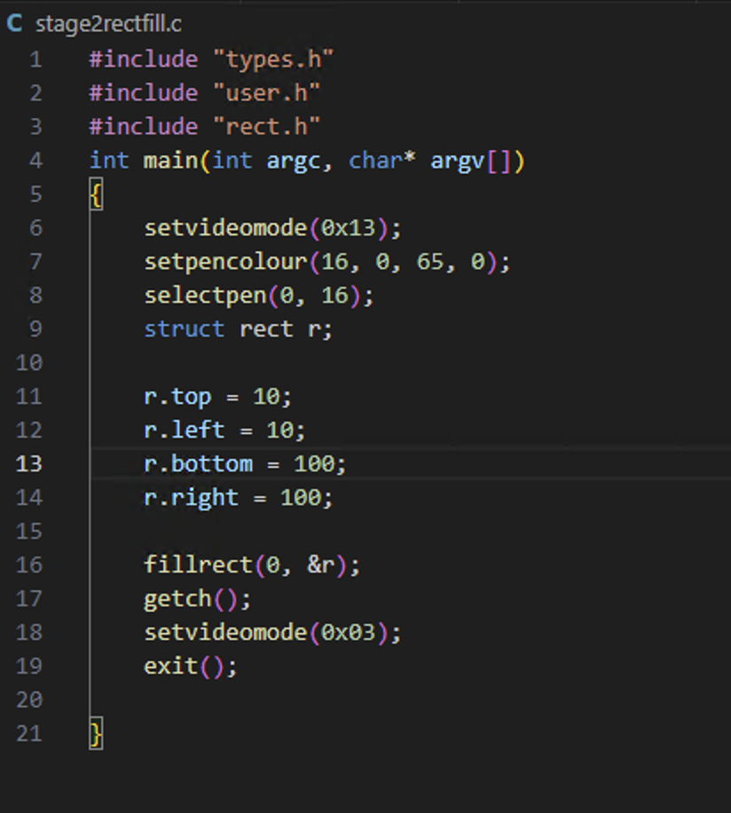

Declaration in Makefile UPROGS:

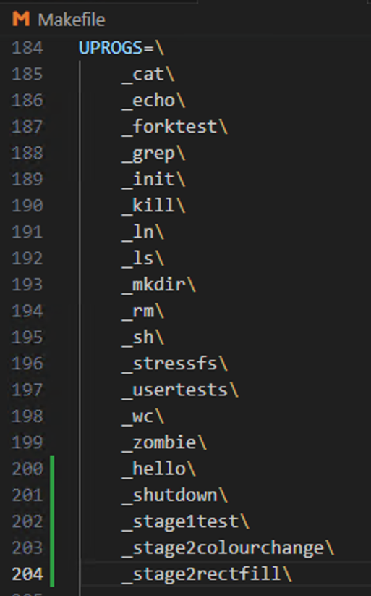

To test if the rectfill works I will now run a make clean, make, make qemu and enter stage2rectfill which should display a green coloured in rectangle:

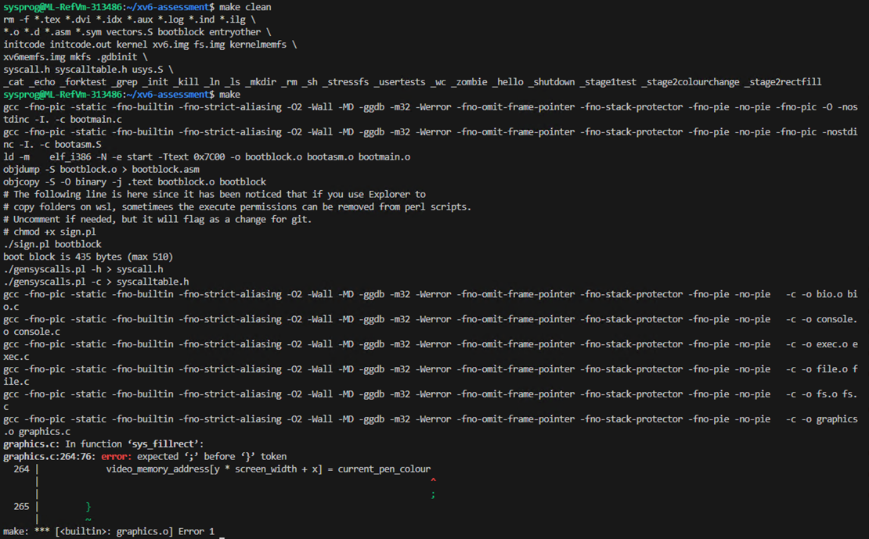

Test Failed

The error occurred and program failed to build. This happened because I forgot to enter a semi colon at line 264 in graphics.c. Heres the fix:

Before:

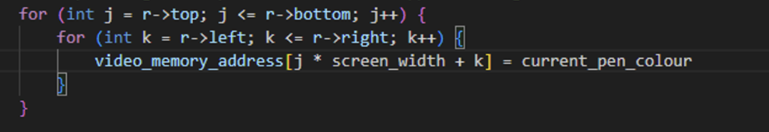

After:

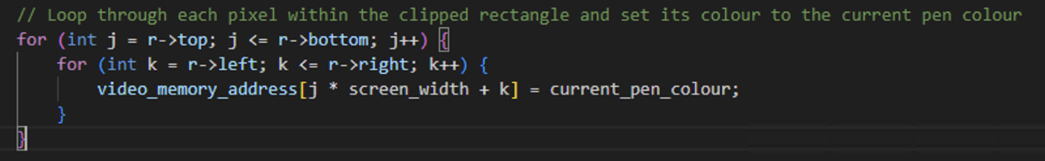

Now to test if this has fixed all the issues in the code I will run a make clean and make:

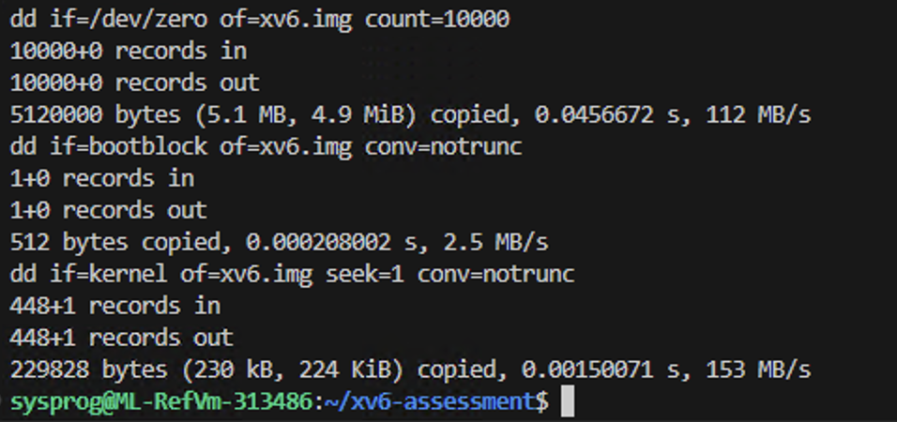

Test Passed

The next test will be to run a make qemu and enter “stage2rectfill” which should display a coloured in green rectangle:

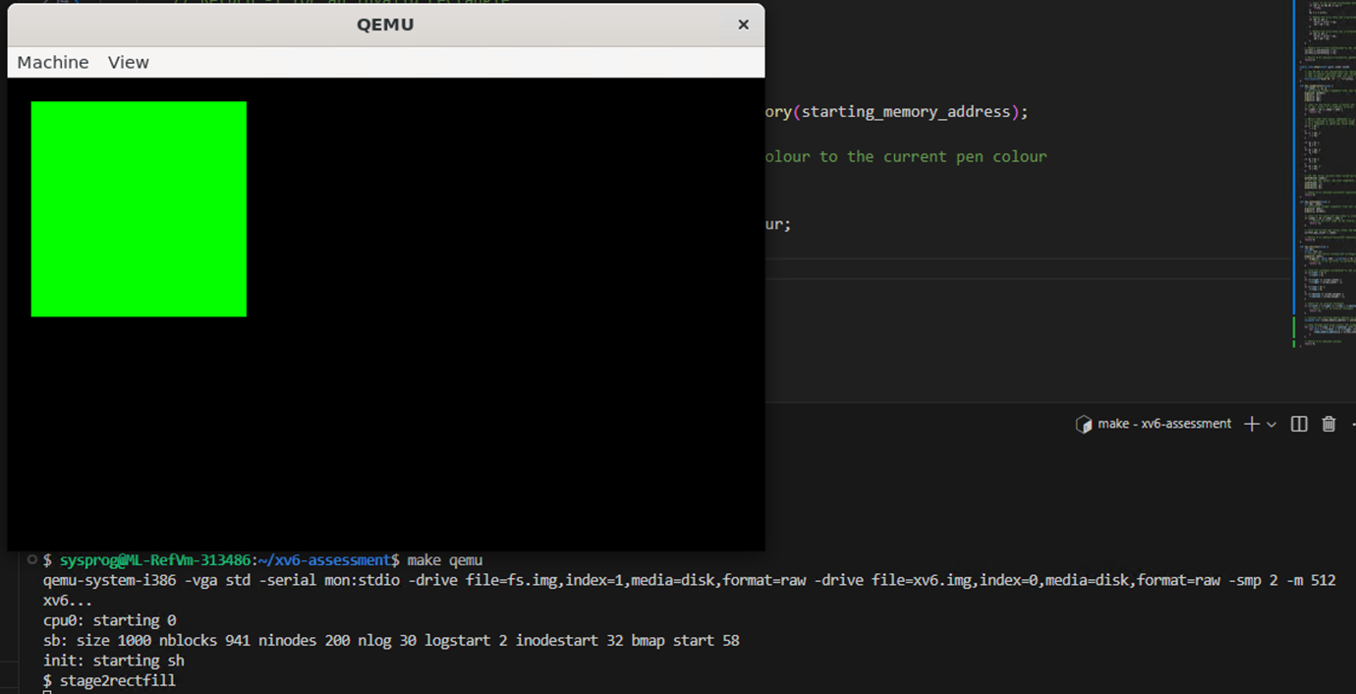

Test Passed

Tuesday 12th December 2022 – 12:00pm – 3:00pm:

Now I have stage 1 and stage 2 completed I showed my code and demonstration to Wayne who said it looked correct just make sure error checking was perfect so the code could not be broken. The following shows how all argptr should be error checked:

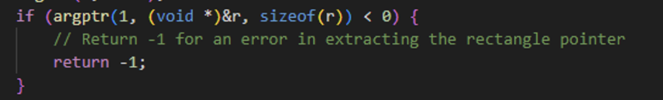

Everywhere drawing/writing to the screen is involved we should be checking the coordinates are on the screen if not clip them like I did here:

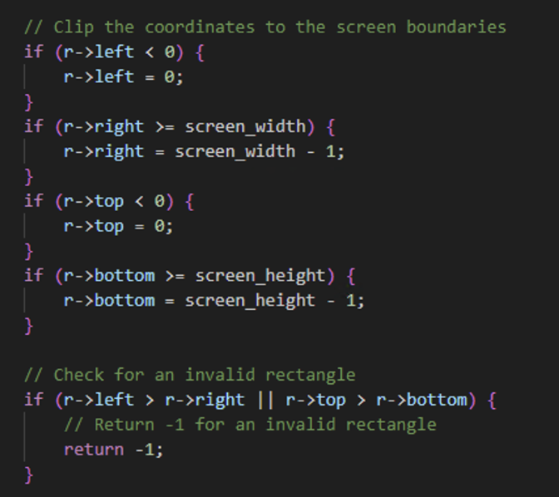

So I took this advice before starting to attempt to implement stage 3 I will put in error checking everywhere. The following is the error check I added to sys_fillrect that I didn’t have before for the hdc. This is a simple check which makes sure the inputted value is above 0 if not return -1 to indicate an error has occured:

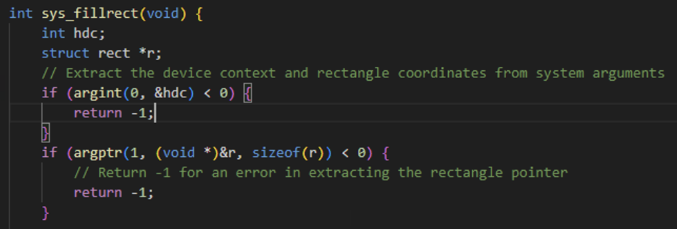

sys_selectpen:

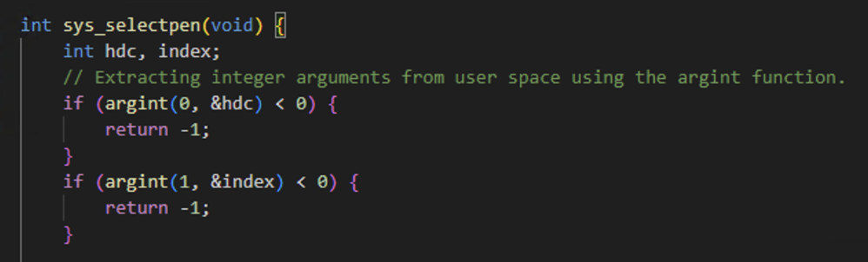

sys_setpencolour:

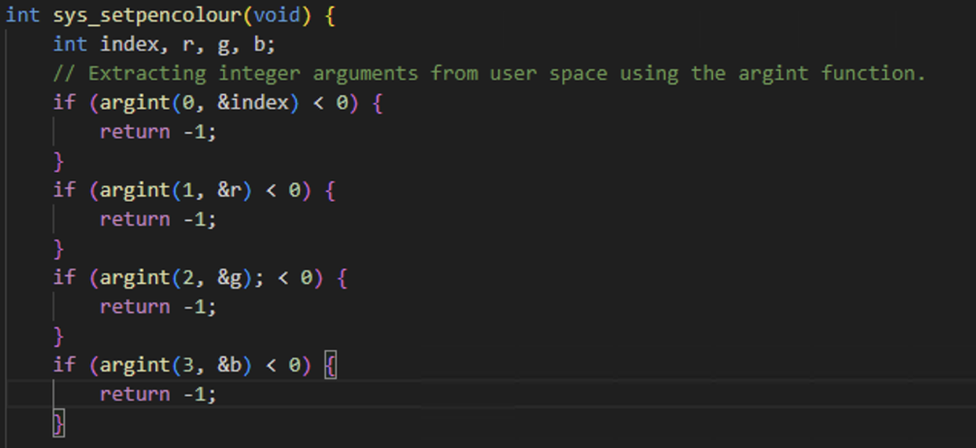

sys_lineto:

The first error check is the basic hdc, x1, y1 to make sure the values are not below 0. I then do a check on x1 and y1 which are the coordinates gained from input and make sure they are not below 0 if they are clip it to 0, if they are above the screen height/width clip it to the maximum screen height/width -1:

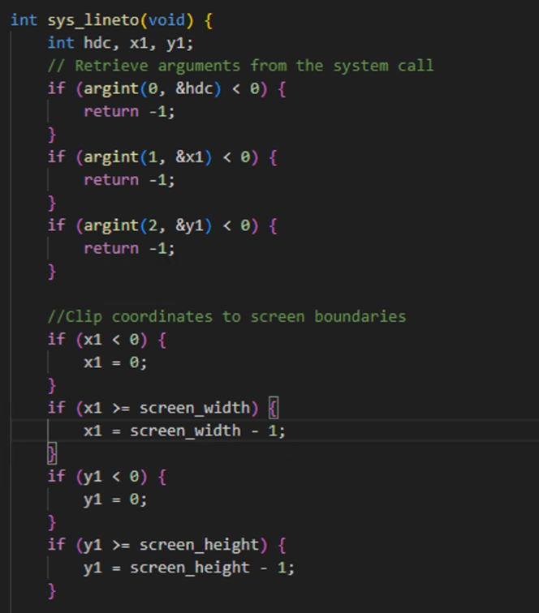

sys_moveto:

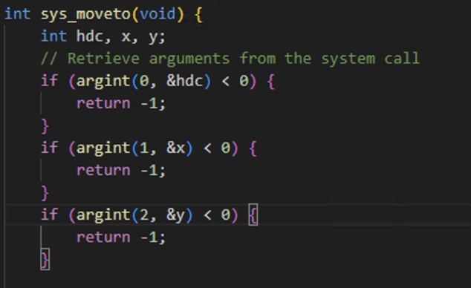

sys_setpixel:

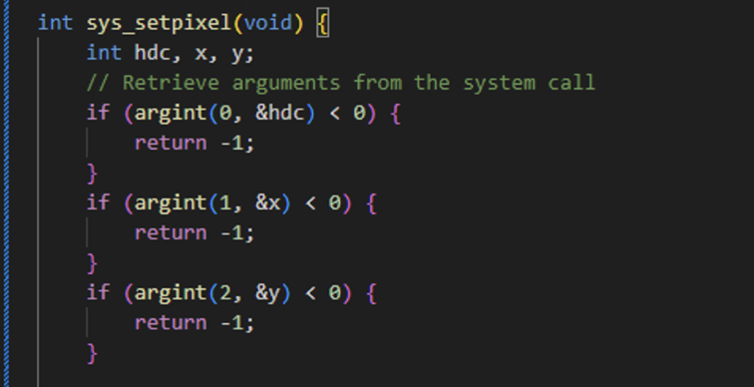

To test this I will run a make and see if the program compiles correctly:

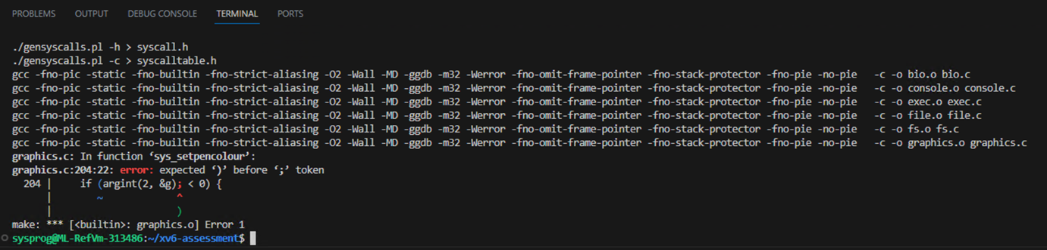

Test Failed

The error was when I was writing an error check for g in sys_setpencolour I forgot to remove the semicolon and it is in the if statement causing the error. The following is the fix:

Before:

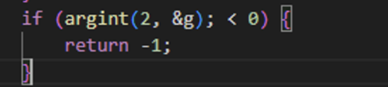

After:

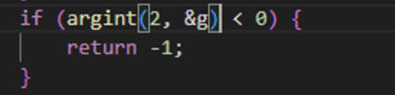

After this change I ran make again and it should compile successfully:

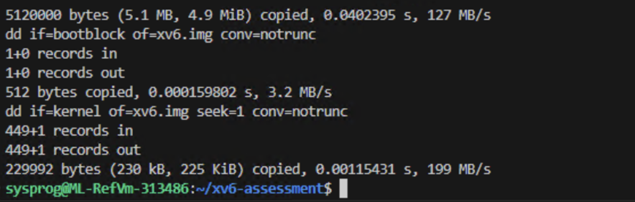

Test Passed

Next I will run make qemu and make sure the program compiles:

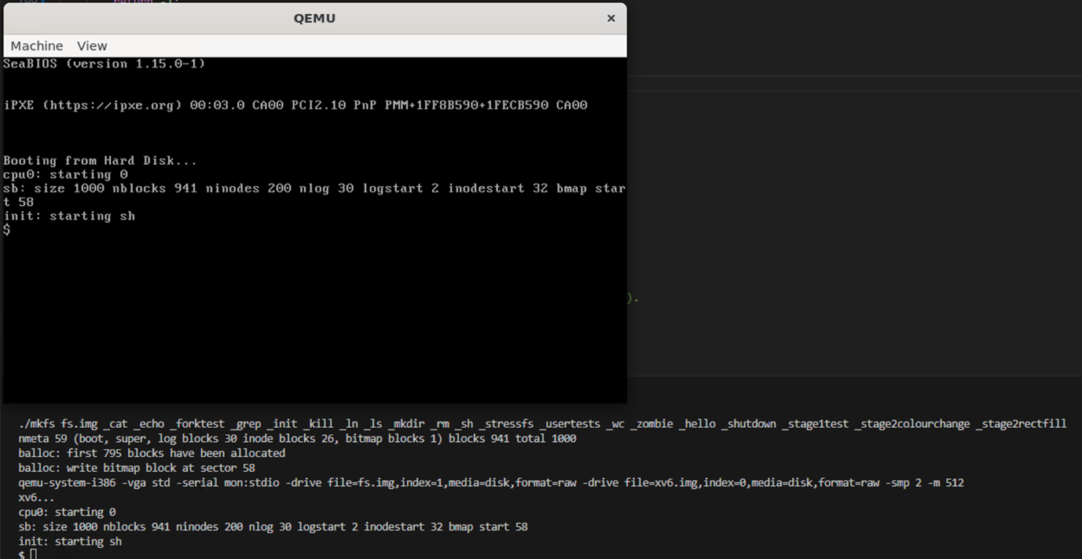

Test Passed

Now the final tests I will run is by running stage1test, stage2colourchange, stage2rectfill calls. To make sure that all the function calls still work as intended. The first test will be running stage1test:

Enter command:

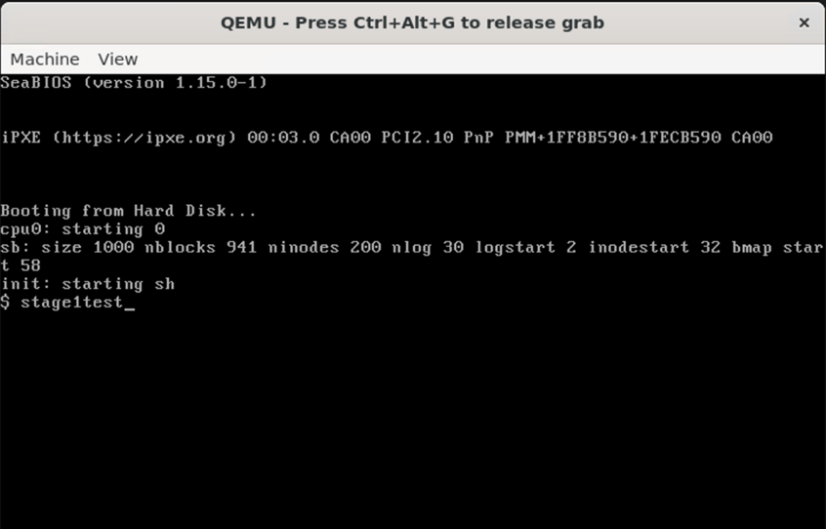

Result:

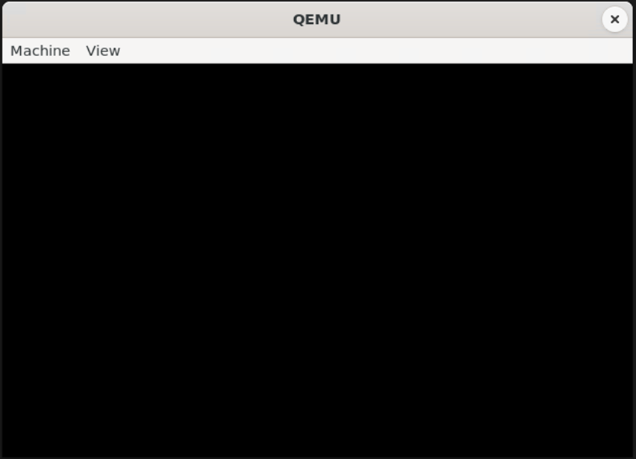

Test Failed

After looking into my code I realised the reason I cannot see the square drawn was because I am not setting the pen colour now as I removed the hard coded colour to get user input. The following is me adding the setpencolour code, which should now draw a red coloured square:

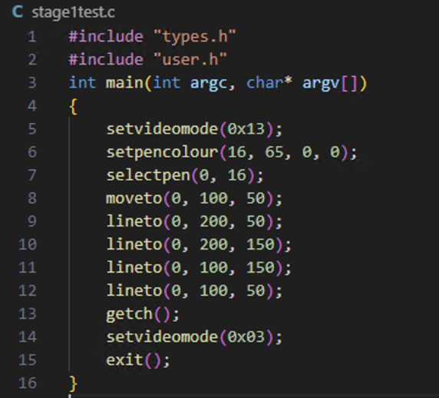

The test I will run now is run make qemu and enter stage1test which should draw a red square:

Enter command:

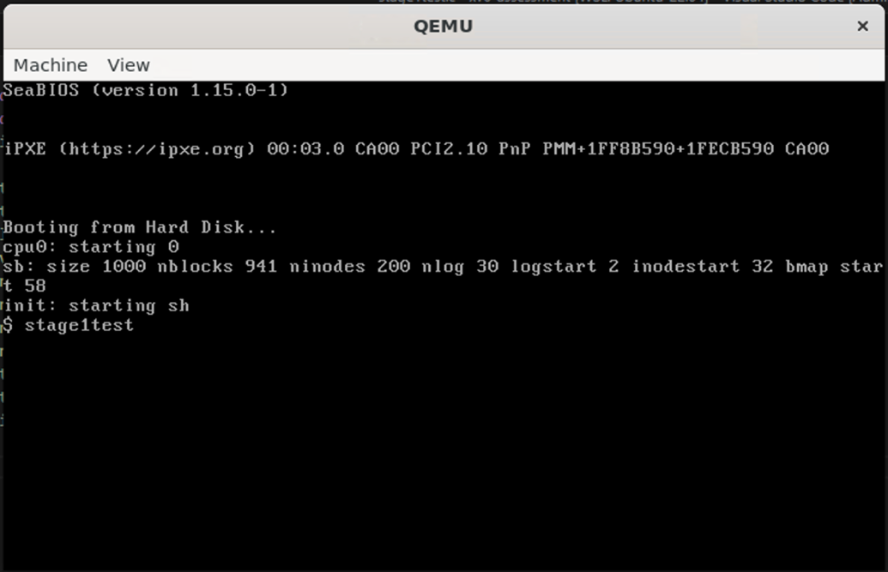

Result:

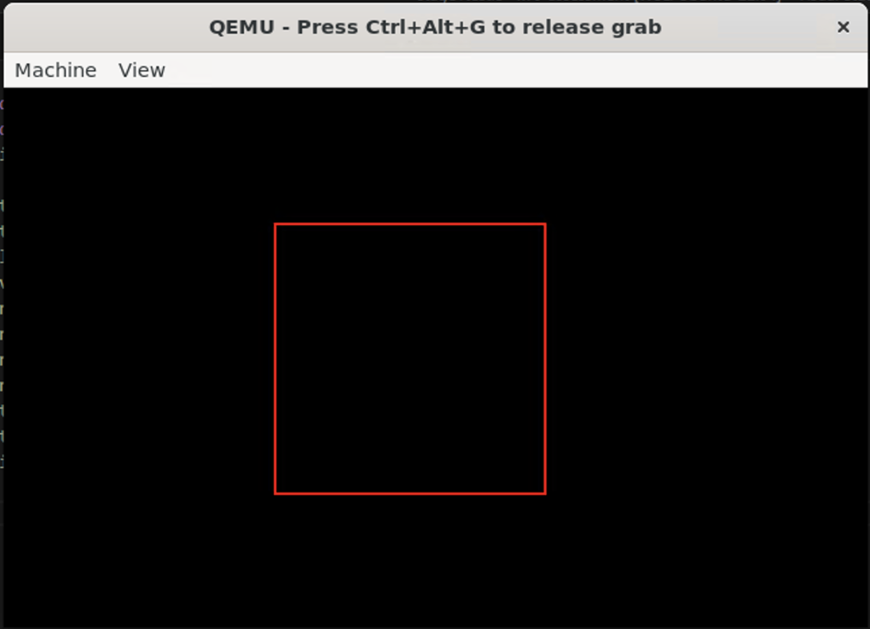

Test Passed

The next test I will run is stage2colourchange:

Enter command:

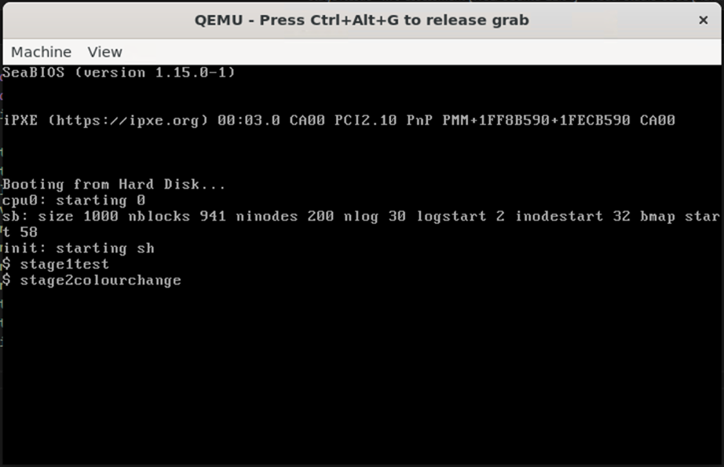

Result:

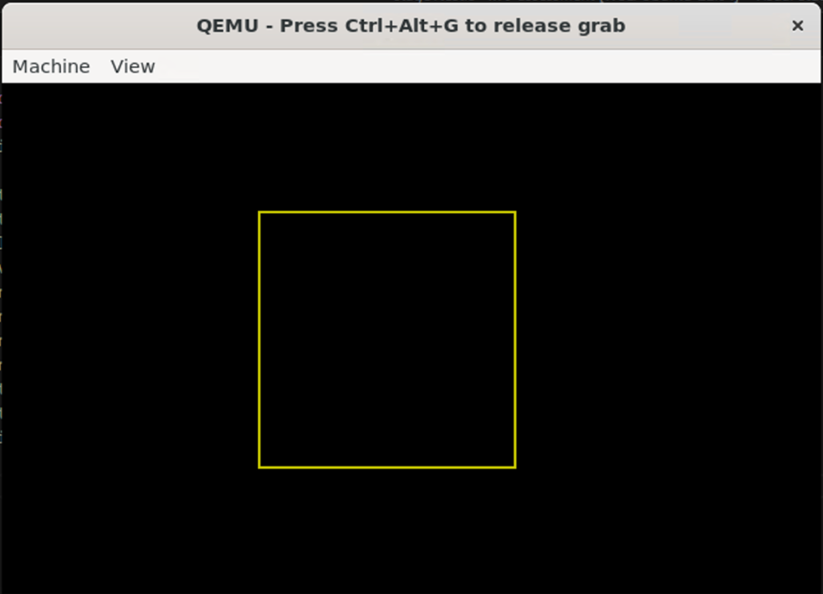

Test Passed

The next test I will run is entering stage2rectfill:

Enter command:

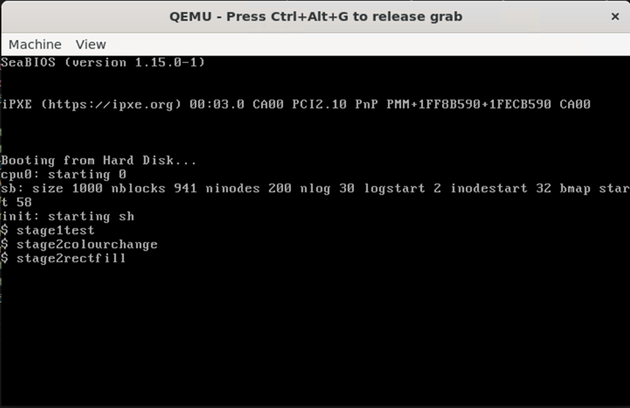

Result:

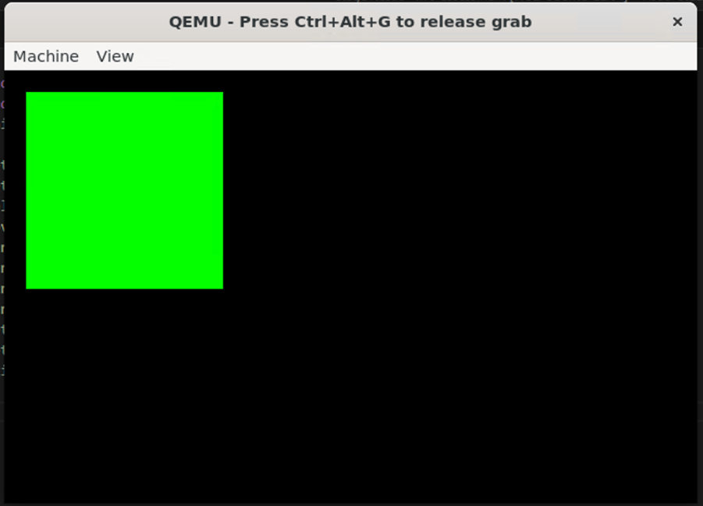

Test Passed

Friday 15th December 2023 – 11:33am – 3:15pm:

Now I have completed stage 2 and added error checking for all the new functions that I added. I now started looking at the rubric and reading the description for stage 3. The first part/task the rubric states I should work on for stage 3 is making a device contect struct that will store the pen, x and y. I first made a new class called devicecontext.h:

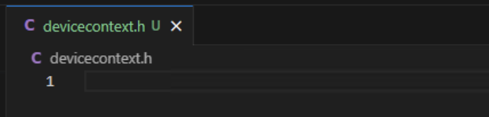

In this class we will have a struct similar to the one in rect but rather than storing rectangle properties we will move the following:

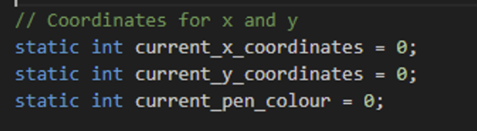

Into this:

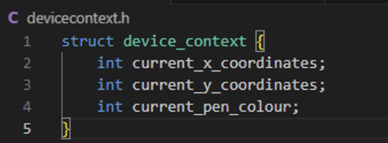

Back in graphics.c I include the devicecontext.h class and then declare a array of device context to manage the different graphical elements. Also declare an array to track the usage status of each of the device contexts: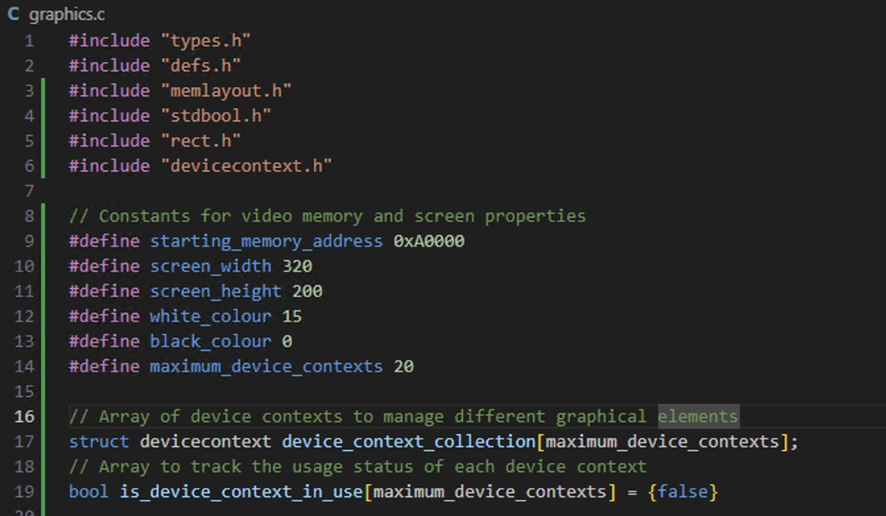

The following are the changes I made in graphics.c to integrate device_context into recording current_x_coordinates, current_y_coordinates and current_pen_colour. The following shows the changes made:

sys_moveto:

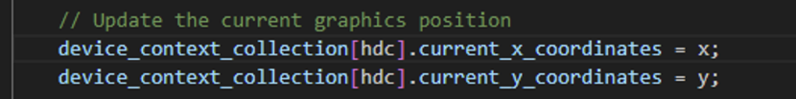

sys_lineto:

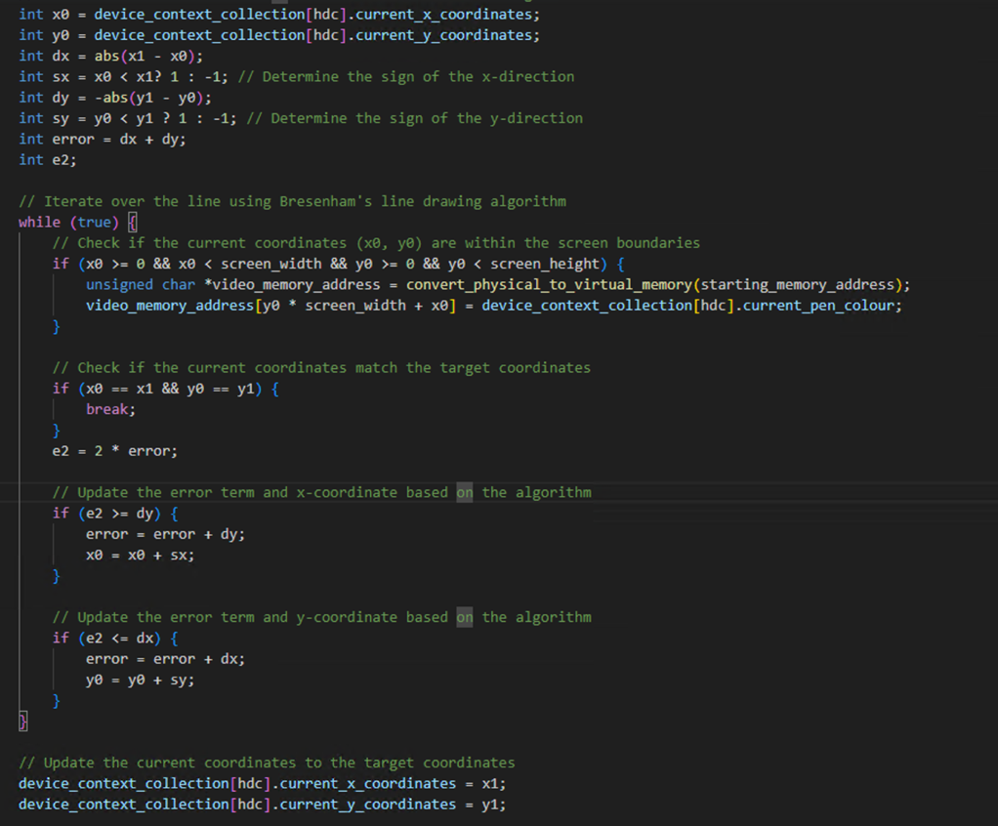

sys_selectpen:

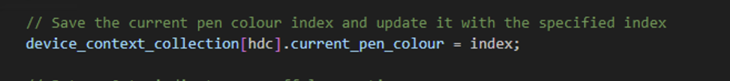

sys_fillrect:

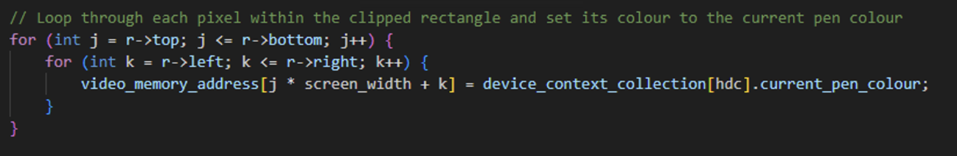

To test if these changes are working I will run make, make qemu and run all the test to make sure they are still working:

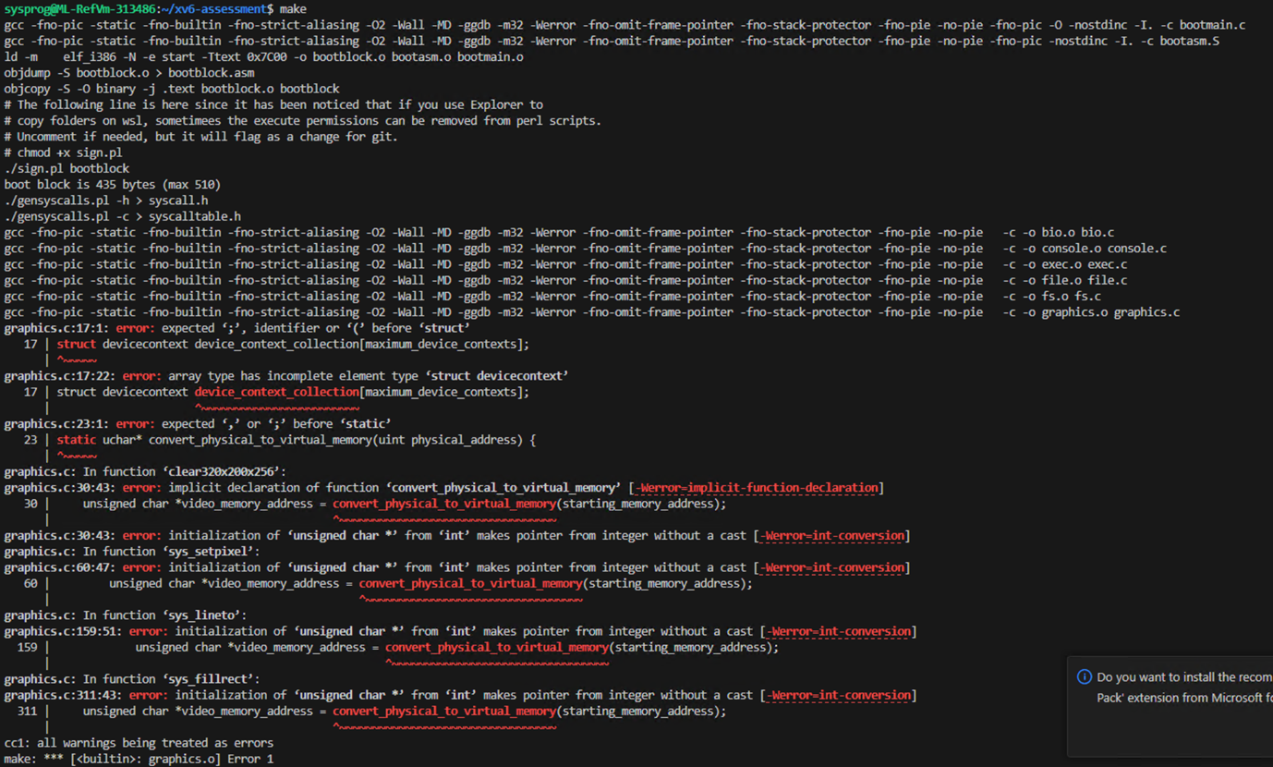

Test Failed

After reading the error and revisiting my code I realised the error was because I forgot a semi colon and the following shows the fix:

Before:

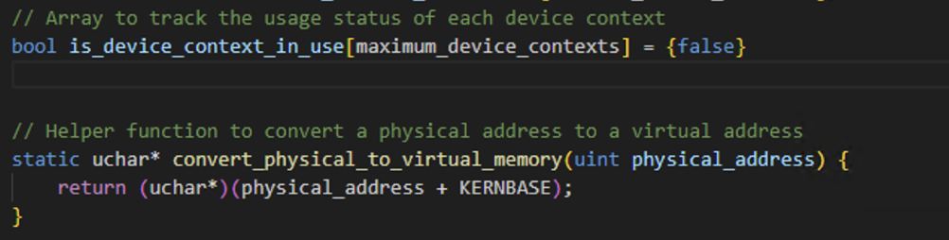

After:

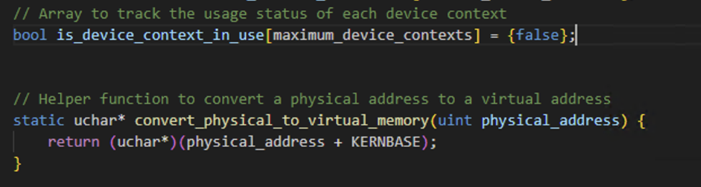

To test if this fixed the errors I will run a make again:

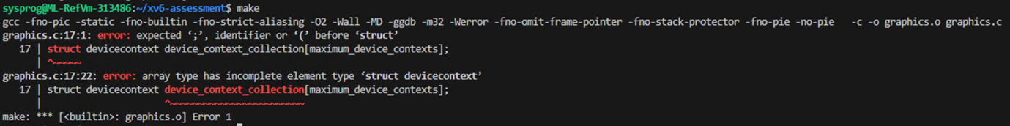

Test Failed

After reading the code and error I realised there were two sections I made an error the first one being that in devicecontext.h I forgot to add a semicolon at the end of the struct:

Before:

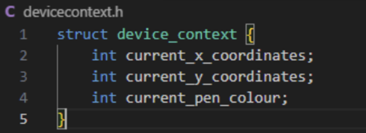

After:

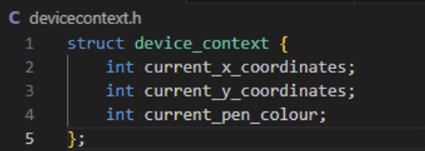

The other mistake was in the graphics.c where I named the struct wrong I called the class name devicecontext rather than the struct name that I want to use device_context:



After:



Now I will run make again to test if the changes I made fixed the errors and it will build correctly:

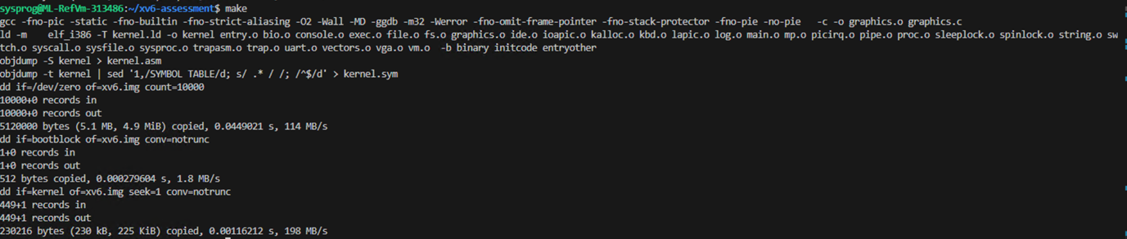

Test Passed

Next I will run make qemu:

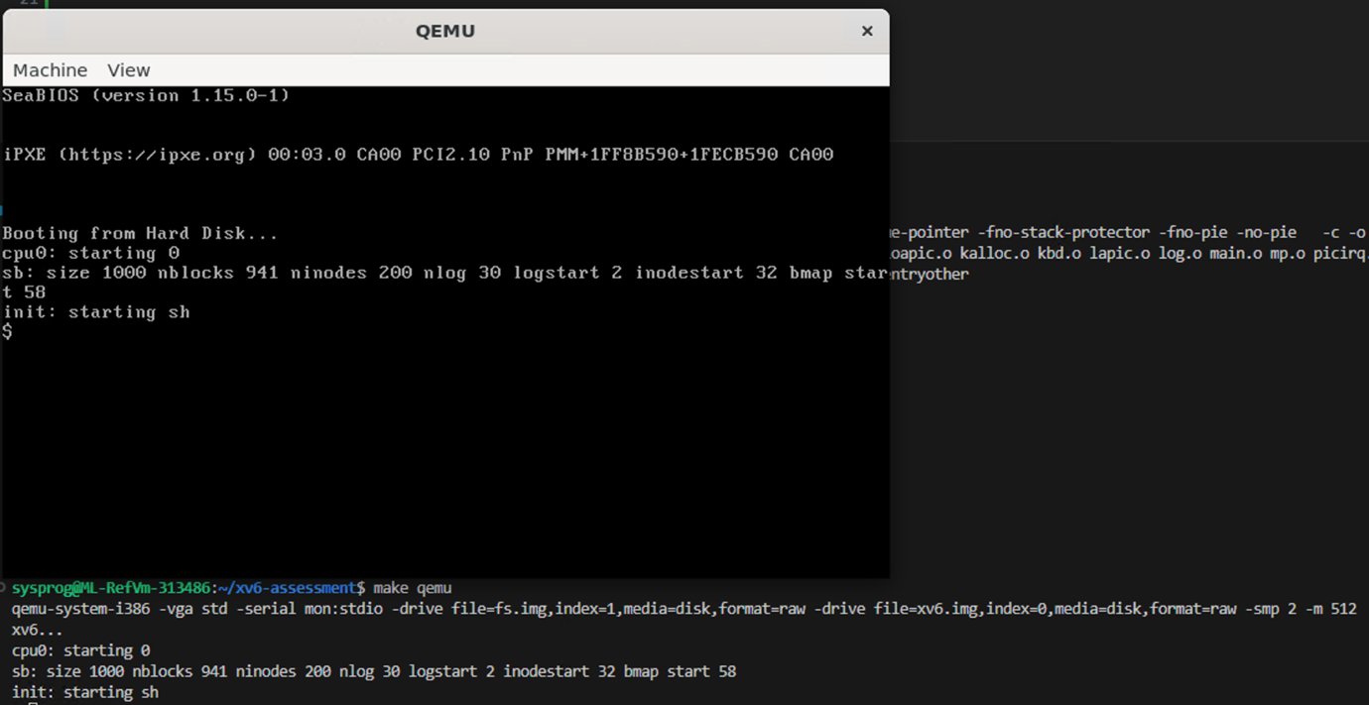

Test Passed

Now I will run all the tests I have written to make sure the code functions the same after the changes. The first test will be to enter stage1test and it should display a red square:

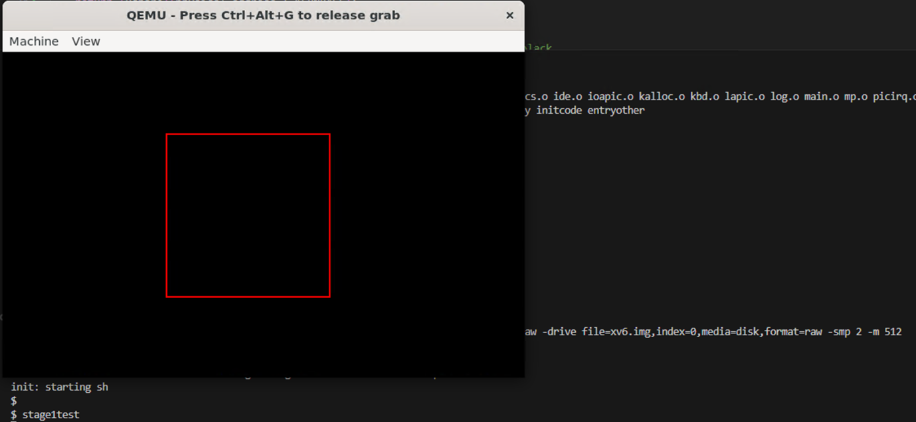

Test passed

The next test will be to enter stage2colourchange and it should display a yellow square:

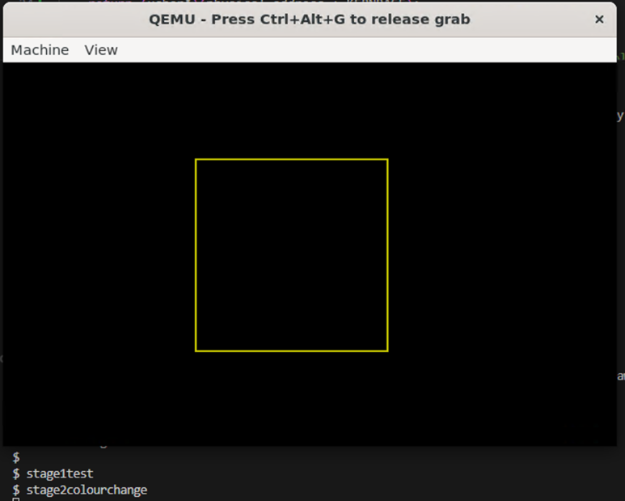

Test Passed

The next test will be to enter stage2rectfill which should display a filled in green square:

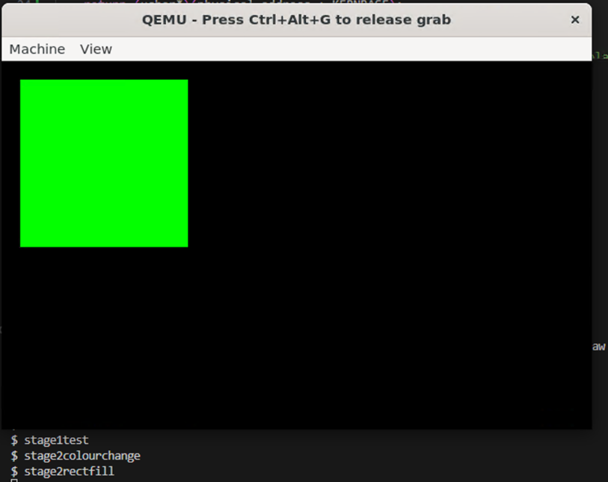

Test Passed

These tests working and now pen, x, y are handled by a struct from devicecontext class and all the tests are working that’s the first part of stage 3 working.

Sunday 17th December 2023 - 12:55pm – 4:45pm:

Now I have device context made and tested to make sure it is working correctly. I will start implementing the next system call that is recommended in the rubric, the “int beginpaint(int hwnd);” and “int endpaint(int hdc);” I first declared the new function is User.h:

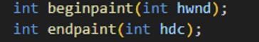

I then added the two funcitons to the gensyscalls.pl in the list of system calls:

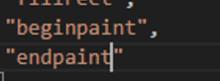

After this I declared both functions in graphics.c. in beginpaint I added in variable for hwnd which gets the hwnd argument from the system argument checks it is larger than 0 if it is not return an error else assign it to the hwnd variable. Similarly in endpaint I added a variable for hdc which checks the system argument inputted and checks if is larger than 0 if not return an error else assign it to hdc:

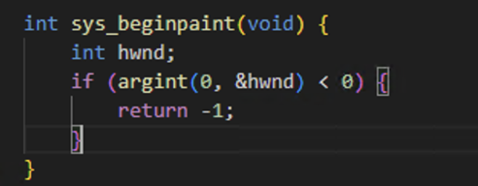

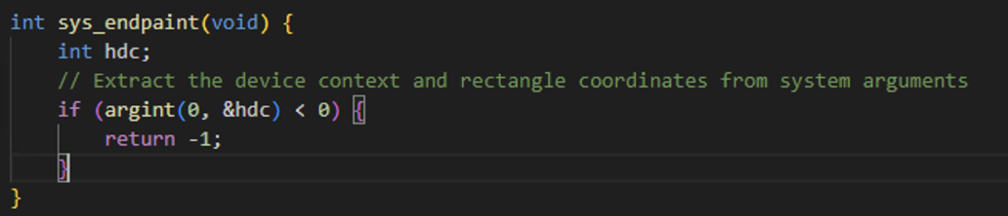

Monday 18th December 2023 – 3:55pm – 7:15pm:

After reading the rubric the following is the code I wrote for the begin pain function. After checking if hwnd argument is above 0. I read the rubric and made sure I understood what it was asking for. After this the following code I wrote is to loop though all the device contexts and it will first check is the device context on the irritation of the loop has been used if it has the program will skip to the next iteration and do the same check until it finds one that has not been used. Once it has found one that has not been used I will change that device context iteration to say it has been used since we will use it. Set the x, y and pen to the default values which are 0 and the colour white and return I which holds the number of the device context that we just set ready for usage:

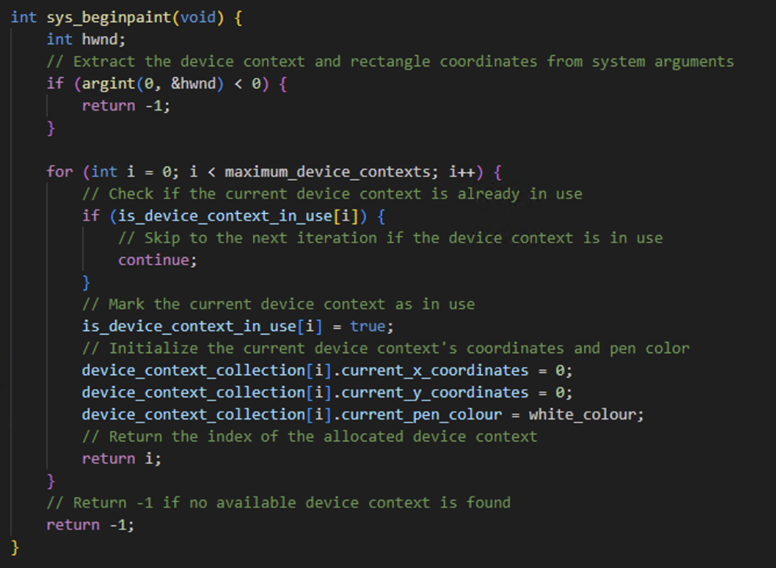

To test this I will need to implement endpaint. So that is what I will attempt next. Before attempting it I read the rubric which also gave information about what this function needs to do. The following function is to be called at the end and it will clear all the x, y, and pen colour of the device context used back to its default. After I check the hdc system argument inputted and make sure it is larger than 0 I have an if statement that will retrieve the device context that is in use and reset all the values back to its default and make the device context ready to use. If the device context index is invalid or in use we will return -1 to indicate an error has occurred.

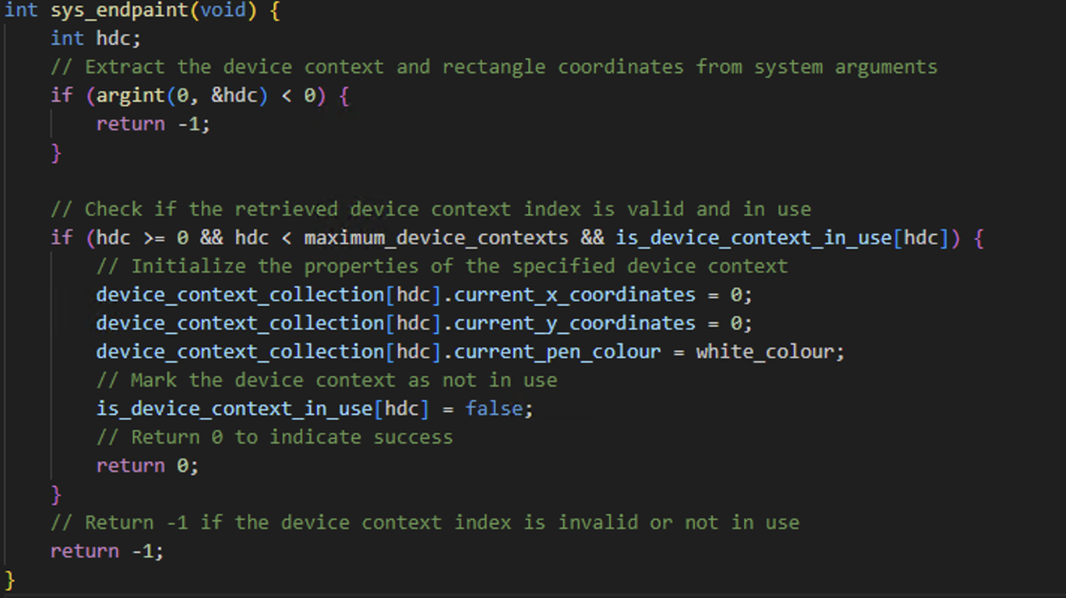

To test this I edited the stage2rectfill to include the begin and end paint I made a few tweaks. I added a int hdc variable which will hold the index for the number of device context that is used. The select pen

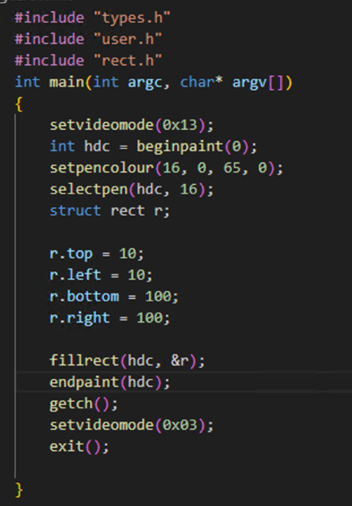

Now the test I will run the make qemu and enter stage2rectfill which should display the square same as before. If it does display the filled in green square same as before show that beginpaint and endpaint are working as intended:

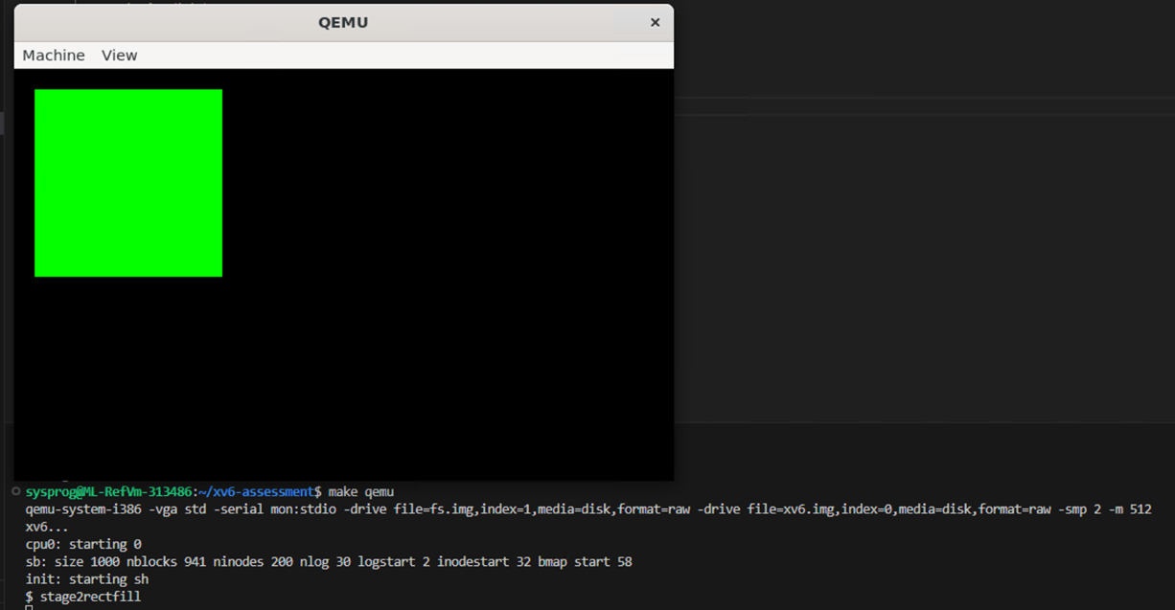

Test Passed

For stage 3 I will write a specific test for it in a file called stage3test:

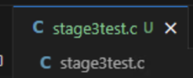

Entered the test in the user level programs so it can be called:

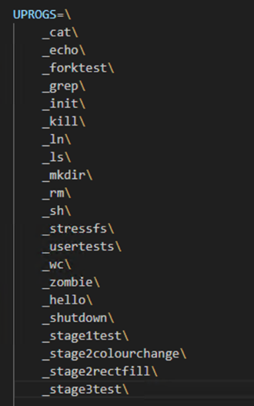

The code for this will display multiple green and blue squares for the user to see, this code was taken from the week 9 lecture where wayne used this to demonstrate his code and explained how it should look to know stage 3 worked correctly. The only changes I made was that I added beginpaint and endpaint. This code demonstrates the working of stage 3 as it uses the graphical calls made in stage 3 device context, start paint and end paint, it paints using 2 different colours and system calls demonstrating that all the functions are working correctly and handling different calls correctly. Also this also demonstrated the error checking functionality added as the blue squares shown in the test are programmed to go off the screen but my error checking that clips the coordinates makes them to be shown on the screen automatically:

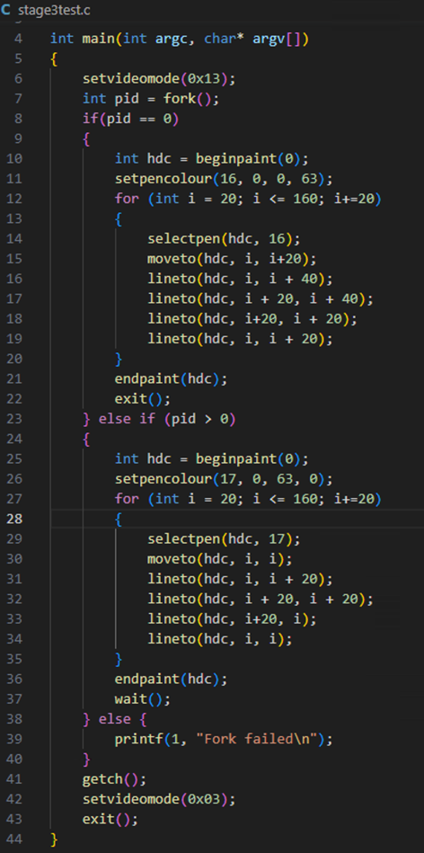

To test if this code works and will draw 8 green squares. I will run my program and enter the stage3test command:

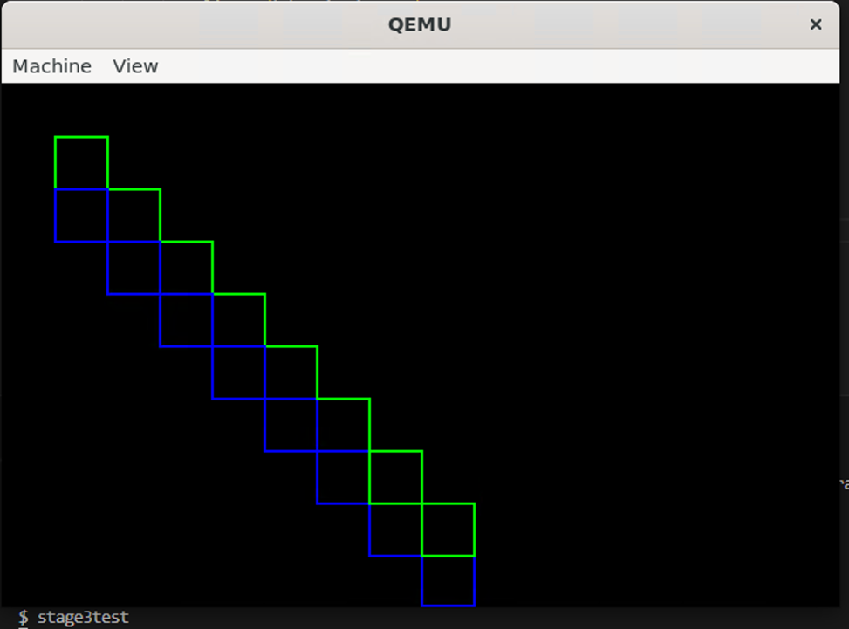

Test Passed

Friday 22nd December 2022 – 1:15pm – 6:13pm:

Today I will tidy up the tests I have written and add extra tests in ready for submission. I added a few user level tests that will let Wayne test using the tests I wrote. The first will be to display a blank screen. I wrote this as one of my first tests I did. I wrote a new filename called blackscreentest.c and here is the code:  
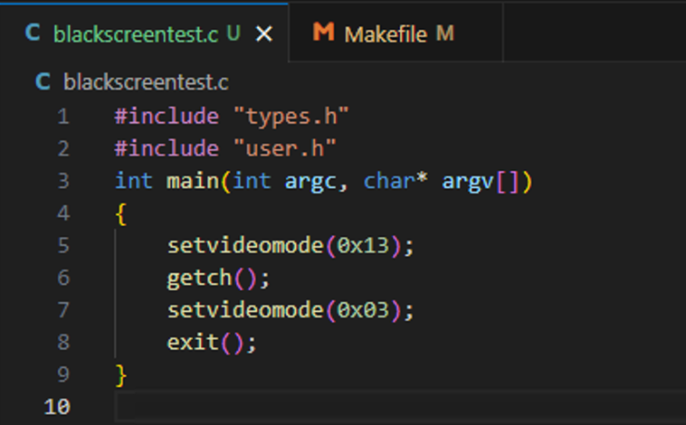

To test if this works I will run the program and enter “blackscreentest” and a empty black 320x200 window:

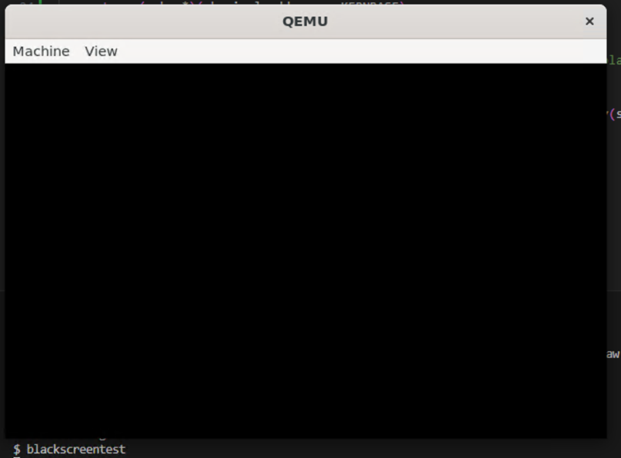

Test Passed

I next made a user level program table at the top of this document that includes the command to for the call a description of what it does and the result I got that and what they should get. The following shows the table I made for this and an example using the first test:

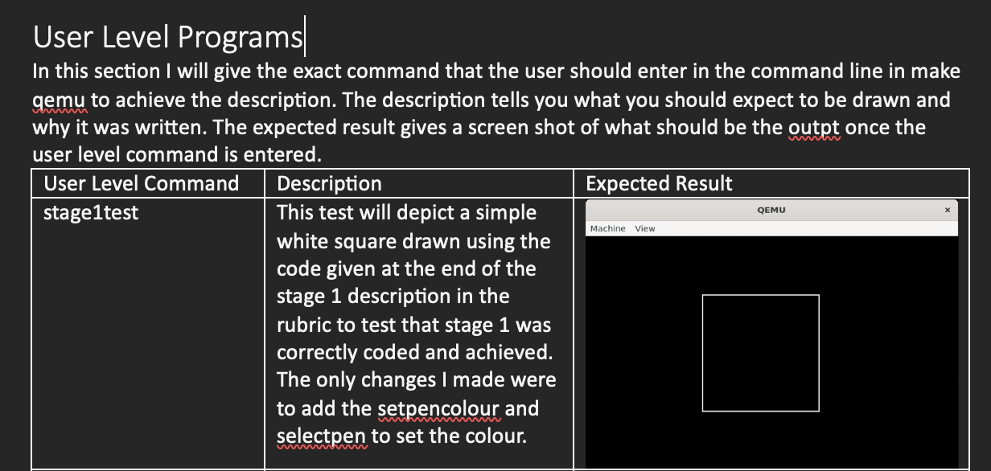

One minor change I made was I renamed the user calls that are there to test stage 2 part 1 and 2 to have test at the end of the call so it is clear they are tests:

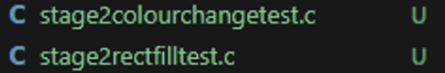

Makefile:

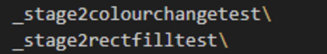

I then tested that the commands were still working by running make qemu and entering both new commands and I expect to see the same results:

Stage2colourchangetest:

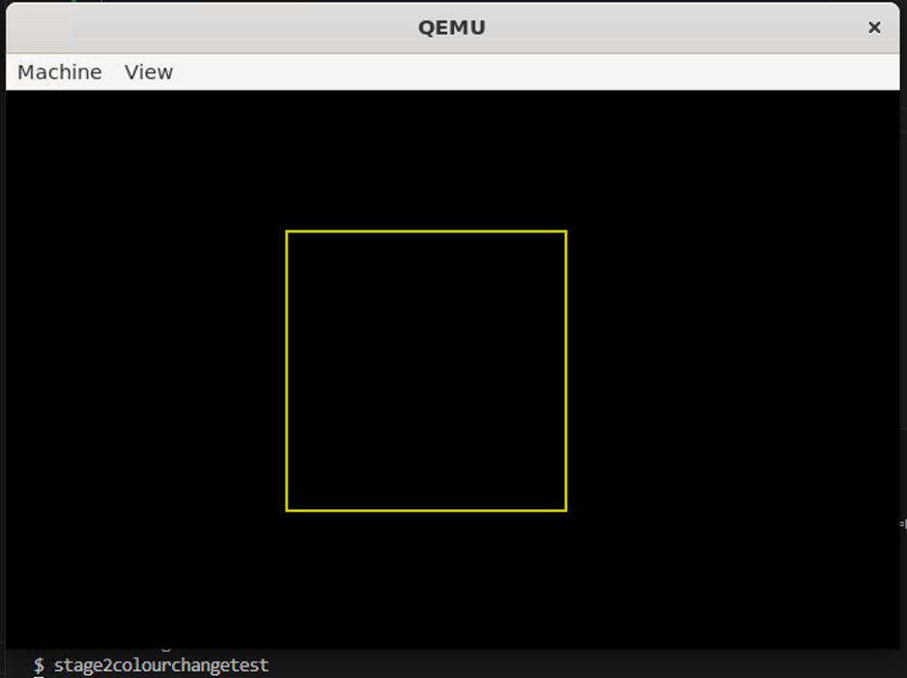

Test Passed

Stage2rectfilltest

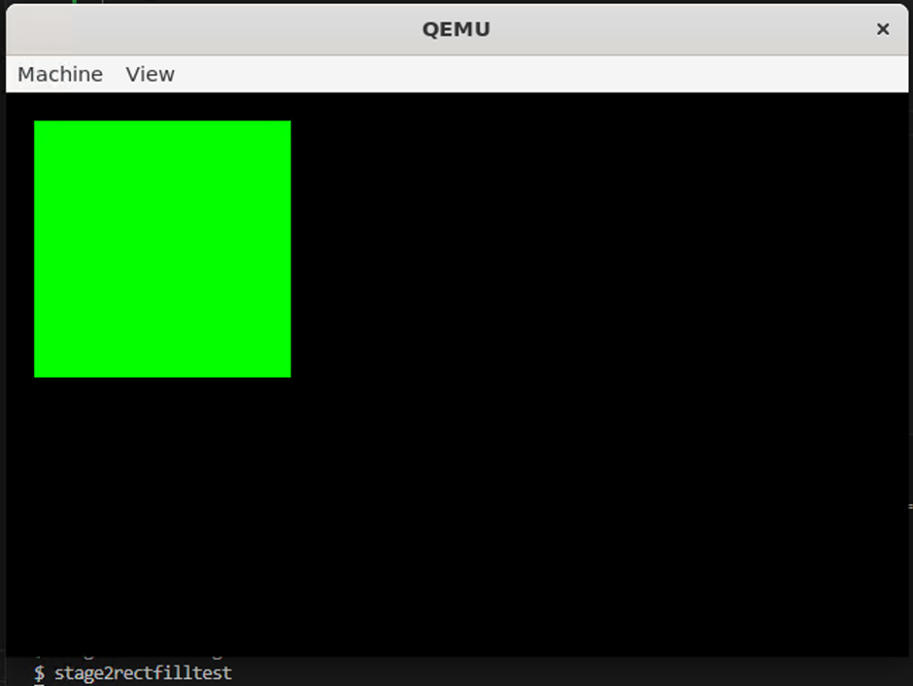

Test Passed

The next test that I re wrote from before was to demonstrate that the set pixel function I implemented was done correctly going to the pixel coordinates set by the user and change that pixels colour. For this I made a new file called setpixeltest.c and added it as a system call to the makefile:

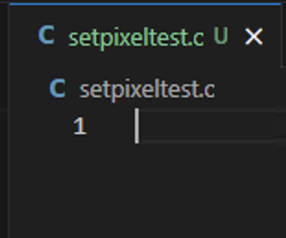

Makefile:

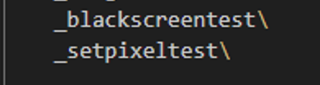

The following is the code I wrote which will set 4 pixels on the screen:

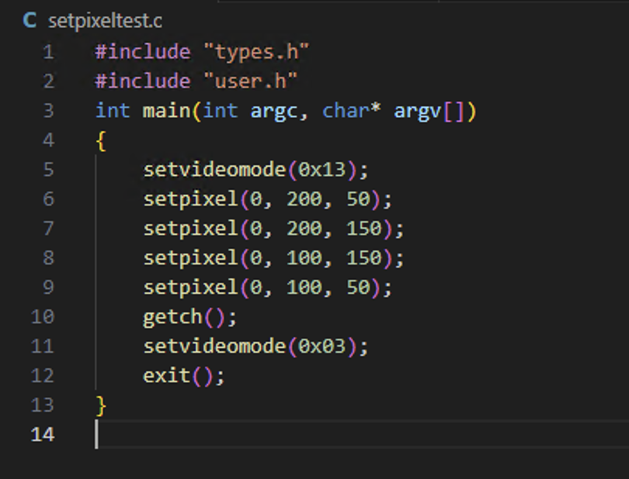

The following is a test I carried out to test if setpixel is working. I will run make qemu and enter setpixeltest:

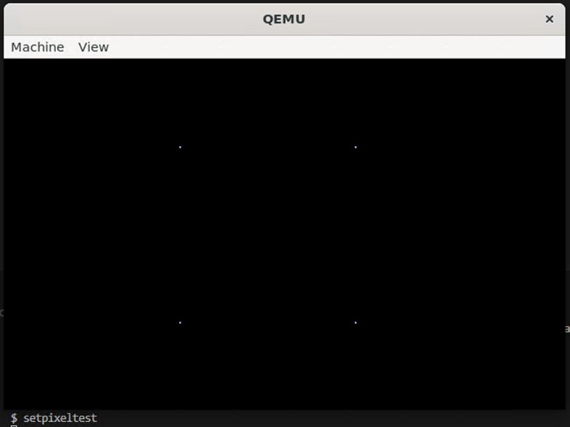

Test Passed

Friday 5th January 2023 – 8:45pm – 9:00pm:

Today I opened my code and tested each of my user level programs making sure they are working correctly. After doing this all worked correctly and I have successfully completed all of stage 3. I ran a make clean and submitted the assignment.